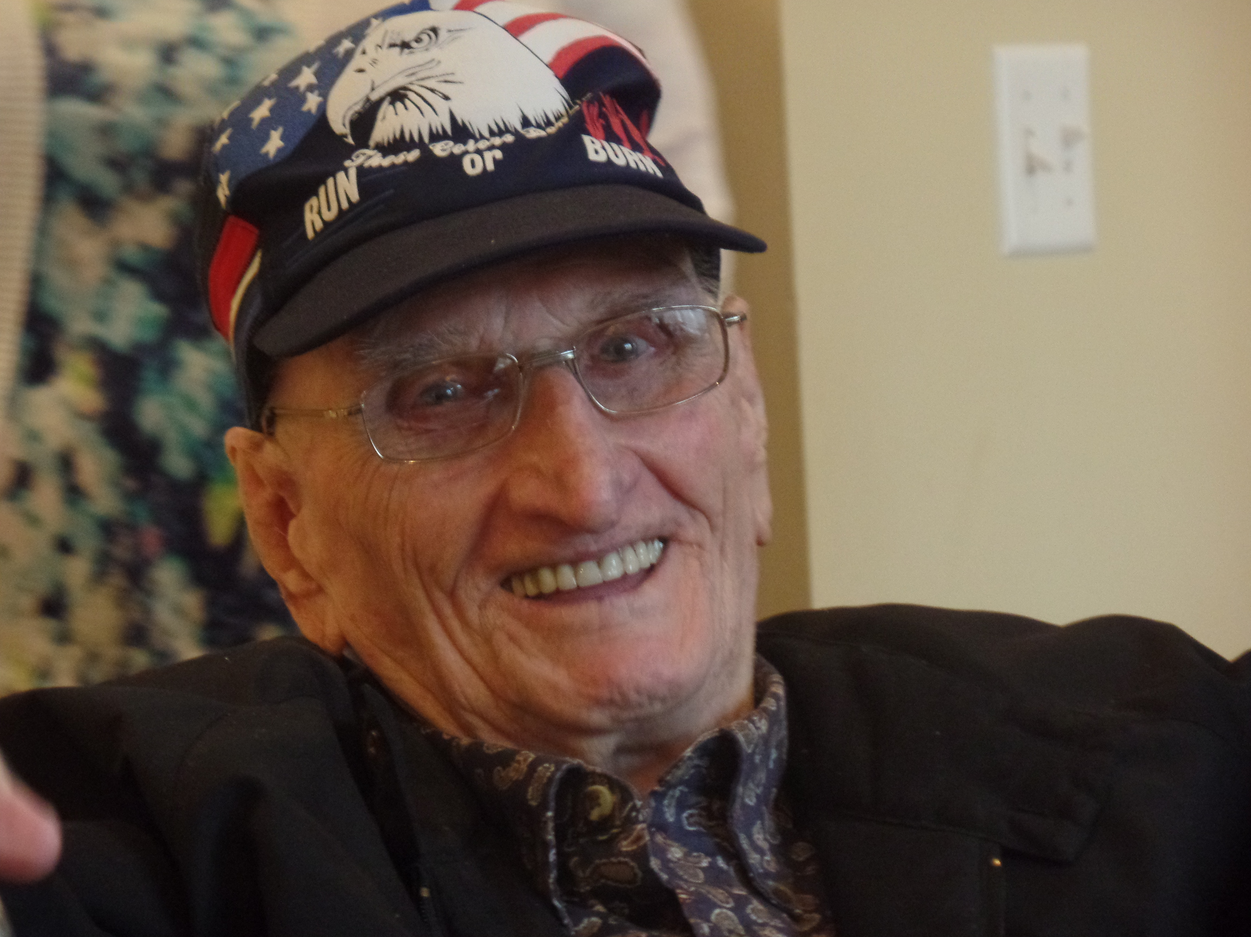
PSS ! It’s My Story
Everett Barker
Born: June 13, 1922
Died: March 10, 2016

Compiled by Everett Barker and Jack Scott
Nixa, Missouri December 2008

PSST !

It’s My Story - Everett Barker

Copyright @ 2008 by Jack Scott. Published by Scott Family Books,
301 Yosemite Dr., Nixa, Missouri, 65714.

Put into PDF form by Roger Fortner - April 2018
You are free to make copies of this book, but can not be sold for profit.

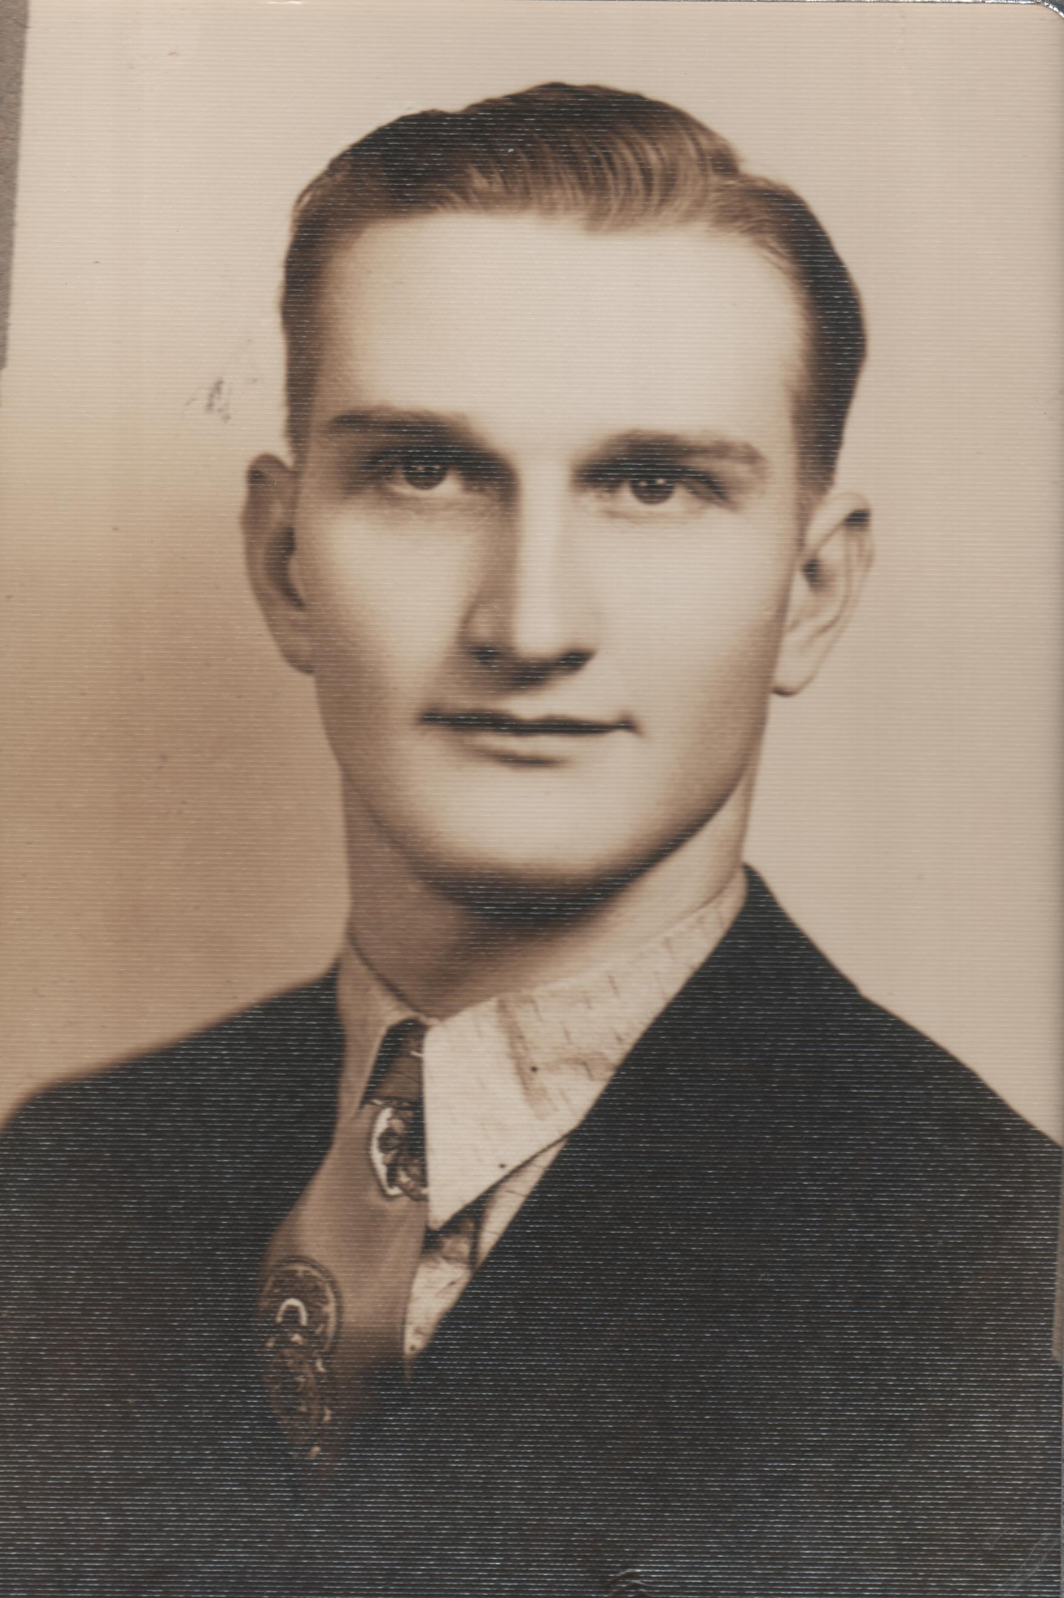

Everett Barker - age 18 - 1941

Table of Contents
Preface
Introduction
Part One

The Roots of My Story 1

John Henry Barker 1853-1910
William Elkaney Barker 1876-1950
Roy Elmer Barker 1896-1986
Part Two

My Story As I Remember It 18

Parents * Farm Life * School * Church
Youth Adventures * Difficult Times
Floydene * Our Children * Military
World War II * Juanita * Travel
Part Three

Related Families 43
John Wingo * Charles Silvey * Andrew Daniel
Part Four

John Henry Barker 72
Descendants * Outline Descendants Tree

Post Script 87

Surname Index 89

PREFACE

This is my story. It’s not one of those action packed stories you see on TV. It’s a real story. The story of a boy born in another time and place far removed from the world as you know it. If you could be carried back to the year 1922 and sit down in the little town of Seymour, Missouri, you would be astonished–better you would be lost. You wouldn’t know the first thing about getting up in the morning, going through the day, or going to bed at night.

You see, there was no electricity in our rural community. No electric lights, no electric stove, no refrigerator, no toasters, no coffee makers, no TVs, no telephones, no hair curlers, no running water, nothing powered by electricity, except the battery-operated radios--they ran off car batteries.

The radios often had more static than sound. When we couldn’t hear very well, one of the kids would go outside and pour water around the ground wire. That seemed to help. When the battery ran down, we took it down town to get it charged.

I was six years old before TV was invented. It was years after that before they were available in homes. Floydene and I bought our first one after we were married–about 1951, I believe. TV games were in the far distant future. Can you imagine a day without them?

When I was a boy, we walked to school. We traveled by wagon to town and church. There were a few Model A Fords, but not many people could afford to own them.

Once in awhile, we saw a plane fly over, but we never dreamed of making a trip in one. The first jet engine was not invented until 1939, so jet passenger planes and space travel were unheard of. Now, I can go on the computer, plan my trip, get discounted tickets, printout a ticket, go to the airport, put the ticket in a machine and fly to any place I can afford.

You guys grew up in the computer age. I never heard of such a thing when I was in school. I was 17 years old (1939) before the first digital computer came into existence. They were not available to the public for several more years.

Disc recordings–games and music–came much later. Our music came from tape players (1942), 33 1/3 rpm records (1948), 45 rpm records (1949), stereo LP recordings (1958), Compact Cassette Recording (1963), and 8-track players (1966). Laserdisc video recordings were not on the market until I was 56 years old (1978). DVD video recordings came on the scene in 1996. I was 74 years old.

The Internet is common place for you. Some of you will not remember when it was not available. Today, children in kindergarten know how to get online, but there was no such thing before 1973. I was 88 years old before the World Wide Web came into existence.

I have lived in exciting and amazing times. God only knows what will come next, but I am ready whatever He has planned.

Introduction

by Jack Scott

You need to understand how this book was put together. Several months ago, Everett and I decided his descendants needed his story. So, he took time to write out his memories in longhand and I typed them.

In my research, I found a lot of information on the Barker, Silvey, Wingo, and related families. I took notes on the source of the information and recorded it in my Family Tree Maker genealogy program.

Some of the research was included in the text, but source notes can be very boring, so most of them were included at the end of the book.

There is no need to tell you this family history is not perfect. Family histories never are–they are in process. You will find errors. Names were often misspelled in old documents. Dates and places were not always recorded properly by census takers and informants. Spelling was often wrong or illegible. So, look over the mistakes and enjoy your history.

PART ONE
The Roots of My Story
John Henry Barker
William Elkaney Barker
Roy Elmer Barker

1
John Henry Barker 1853-1910

My earliest ancestor was John Henry Barker who was born in October 1853 in Virginia. He died in 1910 in Webster County, Missouri at the age of 57.

He married Rebecca Ella Barker. She was born February 22, 1859 in Virginia and died April 19, 1914, in Seymour, Webster County. According to her Death Certificate (#15128), she was born in Kentucky and died in Seymour. She is buried in the Barker Cemetery.

The reference to her birth in Kentucky is not consistent with the 1900 census, but this is not unusual. The informant and transcriber of these documents have much to do with the accuracy of them.

We are not sure, where they were married. It may have been in Virginia, but most likely it was in Kentucky. At the time of the 1900 Census, they had been married twenty-four years. That would have been in 1876, the year William Elkaney, their first child, was born. He was born in Hart County, Kentucky on November 26, 1876.

They were living in Webster County, Missouri on October 17, 1890. The Springfield Bureau of Land Management issued them a land document (#6381) on that date.

It was ten years later, June 25, 1900, before we found them again. They appeared on the 1900 Webster County Census, in the Finley Township: John Barker, age 46, born in October 1853, in Virginia, and his wife, Rebecca E., age 42, born in February 1858, in Virginia. Alpha M., their daughter, was born February 1890, in Missouri. Rosa A., niece, was born May 1895, in Missouri
2

That census indicated Rebecca was the mother of nine children, three of them then living. Their daughter, Alpha, age 10, however, was the only one listed. She was born in Missouri, in February 1890. Their son, William E. Barker, however, his wife Nellie J., and son, Roy E., age 3, were living next door.

Even though the 1900 Census indicates they had nine children, we have record of only two: William Elkaney Barker and Alpha M. Barker.

We will talk about William Elkaney later. He is in Everett's direct line of descent, however, we will include Alpha here.

Alpha M. Barker

Alpha M. Barker was born June 7, 1901, in Webster County and died October 15, 1995, in Rogersville. She married Albert Jennings on October 20, 1912, in Wright, Webster County. He was born about 1892 in Missouri.

We first find Alpha on the 1900 Webster County Census which was enumerated June 25, 1900. She was with her parents: Alpha M., daughter, born February 1890, age 10, born in Missouri.

On 25 April 1910, she was in the home of her mother (Her father had passed away). The census shows: Rebecca E. head, age 52, widow, born in Virginia, parents born in Virginia; Rosa A., daughter, age 15, born in Missouri; and Alla [Alpha], daughter, age 21, born in Missouri.

3

She was married by 1920 and on June 17, 1920 was listed on the Webster County Census with her husband: Albert Jennings, head, age 28, born in Missouri, parents born in Missouri. Alpha, wife, age 29, born in Missouri. Her Father was born in Tennessee, her mother in Missouri. Lena, her only known daughter, age 2/12, was born in Missouri.

William Elkaney Barker 1876-1950
William Elkaney Barker was born November 26, 1876, in Horse Cave, Hart County, Kentucky and died April 26, 1950 in Carthage, Jasper County, Missouri.

He married Nellie Jane Wingo on December 1, 1895, in Webster County. She was born June 1, 1880, in Missouri.

World War I Draft Registration records show he registered for the draft in Seymour.

His death certificate (#13428) states that he was a retired farmer. He died at the age of seventy-three years and five months. He is buried in Park Cemetery, Carthage, Missouri. At the time of his death he resided at 721 Oak St., Carthage.

On the 1900 Webster County Census, numerated on June 25, 1900, William Elkaney, a farmer, was twenty-three years of age. He had been married to Nellie J. for four years and they had three children. Only one, however, Roy E., age 3, was then living.

4

The 1910 Webster County Census, enumerated April 25, shows William, age 33, his wife Nellie, age 22, Roy E., son, age 12, Carrie, daughter, age 9, Volina [Yvonne], daughter, age 7, Ray T., son age 4, and Edna, daughter, age 12.

They appear again on the 1920 Webster County Census, enumerated on January 2. William was 43, Nellie E., 41, Yvonne, 17, Ray T., 14, Edna, 12, and Thelma, 4 6/12. No longer living in the home are: Roy and Carrie.

In 1930, the census shows that William and Nellie are still living in Webster County, with their daughters, Thelma and Doris.

Nellie Jane Wingo 1880 - ?
We did not research the Wingo family, but did find some interesting bits of their history. You will find it in Part Three "Related Families."

Atthis point it is sufficient to say that her father, John A. Wingo, was born in 1844 and died in 1929. He is buried in the Mt. Pisgah Cemetery, Webster County, Missouri..

Her mother’s given name was Anna Eliz. Some research indicates her surname may have been Anderson, but that has not been documented. She was born in 1850 and died in 1930.

5

The Wingo family was living in Livingston County, Missouri on June 18, 1880, at the time of the census. John, age 41, a blacksmith. He was born in Virginia as was his parents. Eliza, his wife, age 39, was born in Missouri. Her father was born in Missouri, but her mother was born in Kentucky.

They had five children: Dora, age 15, Nannie, age 13, Etha, age 13, Annie B., age 7, and Nellie, age 1, all born in Missouri.

The 1900 Census gives us the birth month and year of each individual. The Webster County Census, enumerated June 26, 1900, shows: John A. Wingo, head, born January 1844, in Virginia, age 56, farmer, married 32 years, parents born in Virginia. Ann, wife, born April 1850, age 50, mother of ten children five then living, born in Kentucky, parents born in Kentucky. Earley, son, born May 1883, age 17, Anna F., daughter, born June 1887, age 12. Thomas, son, born August 1889, age 10; and Rebecca E., daughter, born September 1891, age 8. All the children were born in Missouri.

The Wingo family was still living in Webster County on June 26 when the 1910 census was taken: John A. Wingo, head, age 66, farmer, married 42 years, born in Virginia, parents born in Virginia. Anna, wife, age 60, mother of 13 children, 10 then living, born in Kentucky, parents born in Kentucky. Thomas, son, age 20, Arizona, daughter, age 22, and Rebecca, daughter, age 18. All the children were born in Missouri.

The Bureau of Land Management records show John bought land from the U.S. Government on June 14, 1897. It was recorded in the Springfield land office.

6

Children of William Elkaney
And
Nellie Jane Wingo

Roy Elmer Barker

Roy Elmer Barker was born November 26, 1896, in Seymour, Webster County, Missouri and died in November 1986 in Seymour. He was buried in the Seymour Masonic Cemetery.

He married Mabel Silvey, daughter of William Silvey and Lucinda Catherine Cardwell December 1, 1917, in Seymour.

Roy first appeared on the 1900 Webster County Census with his parents and again on the 1910 Census.

By the time of the1920 Census, on January 2, he was married and living in his own home. The record shows: Barker, Roy E., Head, age 23, born in Missouri, father born in Kentucky, mother in Missouri. Mable, wife, age 22, born in Missouri, father born in Kentucky, mother in Missouri. Donald E., son, age 1 1/12, born in Missouri.

The last available census (1930) shows: Roy E. Barker, head, age 33, born in Missouri; Mable, wife, age 33, born in Missouri; Donald E., son, age 11; Howard W., son, age 9; Everett D., son, age 7; and Wayne D., son, age 5.
Carrie Barker

Carrie was born October 28, 1900, in Missouri and died February 23, 1999, in Seymour.
7

She married Fred K. Cornelison August 21, 1918, in Webster County. He was born May 29, 1898 in Missouri and he died October 11, 1989, in Springfield, Missouri.

Nine-year-old Carrie first appeared with her family on the 1910 Webster County Census.

She was married and living in her own home on January 16, 1920, at the time of the Webster County Census. It shows: Fred Cornelison, head, age 21, born in Missouri, parents born in Missouri; Carrie, wife, age 25, born in Missouri, parents born in Missouri; and Ester, daughter, age 8/12, born in Missouri.

We found Carrie and her family again on the 1930 Webster County Census. It shows: Fred R. Cornelison, head, age 32, born in Missouri; Carrie O., wife, age 29, born in Missouri; Esther O., daughter, age 10; Magdalene H., daughter, age 9; Edna O., daughter, age 5; Raymond R., son, age 3; and Anna L., daughter, age 1. All the children were born in Missouri.

Yvonne Barker

We did not find very much information about Yvonne. She was born about 1903 in Missouri, but no record of her death was found.

She married Jay T. Carter who was born about 1905 in Missouri.

Yvonne first appeared on the 1910 Webster County Census with her parents and again on the 1920 Census.

8
The same is true of her husband Jay T. Carter. He showed up with his family on the 1910 and 1920 Webster County Census records, but that is all we know about him.

Ray T. Barker

Ray was born October 1, 1905 in Seymour, Webster County and he died in January 1980, in Seymour. He is buried in the Seymour Masonic Cemetery.

Ray married, but we did not find her name. She lived with him in San Francisco California, but did not return with him to Seymour.

Ray was on the 1910 and 1920 Webster County Census with his parents and siblings. We could not find him on the 1930 Census. He may have been incarcerated at that time. There is an article in the Jefferson City Post Tribune, dated 1929 with the heading Ray Barker Trial.

He was convicted of shooting a woman about that time and served four years in the state penitentiary in Jefferson City. We know little about this conviction so the story should be investigated in Jefferson City.

Ray served in the Army (unable to find record). After his discharge, he went to San Francisco, California, where he lived for many years.

Edna Barker

Edna was born July 27, 1907, in Seymour and died in January 1981, in Omaha, Nebraska. She was found with her parents on the 1910 and 1920 Webster County Census.

9

We do not know when she married. But she was living in Douglas County, Nebraska with her husband on April 9, 1930. The census shows: Floyd J. Todd, head, age 25, born in Missouri. Edna L., wife, age 22, born in Missouri. Robert M, son, age 4, born in Nebraska; Maxine D., daughter, age 2, born in Nebraska; and Wanda E., daughter, age 3/12, born in Nebraska.

Thelma Barker

Thelma was born about 1916 in Webster County and died in Carthage, Jasper County, Missouri. We were unable to find the exact dates.

She married Eugene Denny on May 27, 1933, in Webster County. He was born May 10, 1914 and died March 31, 1991.

Thelma was found on the 1920 and 1930 Webster County Census with her parents, but we could not trace her any further.

Doris Barker

Doris was born about 1925 in Webster County. We have no record of her death, but the Doris Hubbard who appears in the Social Security Death Index, may be her. It reads: Doris E. Hubbard. Birth: 22 April 1926. Death: 14 June 1993. Last Residence: Salisbury, Chariton, MO. SS# 497-24-7596. Issued: Missouri.

Doris was the last child at home. She is the only child who appears with her parents on the 1930 Webster County Census.

10

Doris married Herschel G. Hubbard in Webster County, but the date is unknown. We know it was after 1943, because Herschel enlisted in the military on September 14, 1943 and was single at that time. He was admitted into the army at Jefferson Barracks, Kansas City. His occupation was Auto Serviceman.

Roy Elmer Barker 1896-1986
Roy Elmer Barker was born November 26, 1896, in Seymour, Webster County, Missouri and died in November 1986 in Seymour. He was buried in the Seymour Masonic Cemetery.

He married Mabel Silvey, daughter of William Silvey and Lucinda Catherine Cardwell, December 1, 1917, in Seymour.

Roy first appeared on the 1900 Webster County Census with his parents and again on the 1910 Census.

On January 2, 1920, he was married and living in his own home. The census record shows: Barker, Roy E., Head, age 23, born in Missouri, father born in Kentucky, mother in Missouri. Mable, wife, age 22, born in Missouri, father born in Kentucky, mother in Missouri. Donald E., son, age 1 1/12, born in Missouri.

The last available census (1930) shows: Roy E. Barker, head, age 33, born in Missouri; Mable, wife, age 33, born in Missouri; Donald E., son, age 11; Howard W., son, age 9; Everett D., son, age 7; and Wayne D., son, age 5.

11

Children of Roy Elmer Barker
and
Mable Silvey

Donald Eugene Barker

Donald was born October 19, 1918, in Seymour, Webster County and died September 13, 2002. in Seymour.

He married Mildred E. “Nadine” Pruett in Webster County. She was born January 26, 1921, in Webster County and died February 18, 2001, in Carthage, Jasper County.

The first record we have of Donald is on the 1920 Webster County Census. He was only one year old and living with his parents.

He was still living with his parents on the 1930 census along with his brothers: Howard, Everett, and Wayne.

There was a rather long obituary posted on Findagrave.com that gives us a good record of his family. It reads: Donald Eugene Barker, son of Roy E. and Mable Silvey Barker, was born October 19, 1918, near Seymour, Missouri. He departed this life Friday, September 13, 2002, in his home, in Seymour, Missouri, at the age of eighty three years, ten months, and twenty four days. On February 3, 1947, he was united in marriage to Mildred "Nadine" Pruett, and to this union two daughters were born. His parents preceded him in death. Donald is survived by his loving wife of fifty-five years, Nadine, of the home; two daughters, Violet Stinnett, and Diana Bowers, and her husband, Eddie, all of Seymour, Missouri; three granddaughters, Tracy and Kelly Stinnett, both of Seymour, Missouri,
12

and Tara Williams, and her husband, Brian, of Chelsea, Oklahoma; two grandsons, Brian Bowers, and his wife, Cindy, and Steven Stinnett, and his wife, Patty, all of Seymour. Five great grandchildren, Emily, Bryson, and Preston Bowers, and Logan and Vanessa Stinnett; three brothers, Wayne Barker, and his wife, Mollie, of Seymour Missouri, Everett Barker, and his wife, Juanita, of Nixa, Missouri, and Howard Barker, and his wife, Billie, of Tacoma, Washington; a sister, Annabelle Ashley, of Seymour, Missouri; several nieces and nephews; as well as a host of other relatives and friends. He was born and raised in the Seymour community and graduated from Seymour High School. He served his country faithfully in the United States Navy from September 26, 1939 until March 2, 1946, during World War II. After being honorably discharged from the Army, he returned to Seymour, where he married Nadine, and they lovingly raised their daughters. For several years he was employed in radiator repair for Auto Mart in Springfield, Missouri, before retiring. Donald had made his profession of faith in Christ and was a member of the Seymour Holiness Church. In his spare time he liked being outdoors where he enjoyed fishing, hunting, and caring for his garden and lawn. His family was very important to him and he especially enjoyed his grandchildren. Donald was a loving father, grandfather, great grandfather, brother, and uncle, and was a caring neighbor and friend. He will be fondly remembered and greatly missed by all those who knew and loved him. Donald served in the Navy during WWII. The U.S Veterans Grave Sites 1775- 2006, shows: Donald E. Barker BM2 US Navy WWII. Birth: 19 October 1918. Death: 13 September 2002. He is buried in the Seymour Masonic Cemetery.

13
William Howard Barker

William Howard was born in 1920, but we were unable to locate his birth or death records.

We know he married Billie Alexander on October 11, 1941, in Webster County. She was born June 10, 1925 in Webster County and died in January 1984, in Seattle, King County, Washington
Howard first appeared on the 1930 Webster County Census with his parents and siblings: Donald E., Everett, and Wayne. We were unable to locate any other records.

Everett Dean Barker

PSST! This is My Story. Since it is My Story, I get more space. It follows in PART TWO.

Wayne David Barker

Wayne was born about 1924, in Seymour, but we do not have a record of his birth or death. He married Mollie Blankenship, but again we do not have any dates. According to his brother, Everett, he did not have any children.

The one and only record we have of him is on the 1930 Webster County Census, where he appeared, at the age of 5, with his parents and siblings.

Annabelle Barker

Annabelle was the only daughter in the family. She was born May 9, 1933, near Seymour in Webster County and died March 14, 2006, in Seymour.
14

She married Willie “Junior” Ashley on February 17, 1951, in Seymour. To this union two sons and one daughter were born.

The following information was taken from her obituary: Annabelle Ashley, daughter of Roy Elmer and Mable (Silvey) Barker, was born May 9, 1933, near Seymour, Missouri. She departed this life Tuesday, March 14, 2006, in the Cox Medical Center South, in Springfield, Missouri, at the age of seventy two years, ten months, and five days. On February 17, 1951, she was united in marriage to Willie "Junior" Ashley and to this union two sons and one daughter were born. She was preceded in death by her parents; her husband, Junior, on October 19, 1994; and a brother, Donald Barker. Annabelle is survived by two sons, Jim Ashley, and his wife, Sandy, of Seymour, Missouri, and Bob Ashley, and his wife, Donna, of Hollister, Missouri; a daughter, Janet Lovelace, and her husband, Ken, of Rogersville, Missouri; six grandchildren, Michael and Steven Sparkman, of Springfield, Missouri, Alissa Blair, and her husband, Keith, of Ozark, Missouri, Taylor Ashley, of Hollister, Missouri, Martin Lovelace, and his wife, Amy, of Springfield, Missouri, and Josh Lovelace, and his fiancée, Carmen, of Springfield, Missouri; three brothers, Howard Barker, of Tacoma, Washington, Everett Barker, and his wife, Juanita, of Nixa, Missouri, and Wayne Barker, and his wife, Mollie, of Seymour, Missouri; a sister-in-law, Nadine Barker, of Seymour, Missouri; a number of nieces and nephews; as well as a host of relatives and friends. She spent her whole life in Seymour, where she and Junior lovingly raised their family. She was a devoted homemaker and an especially good

15

mother to her children. Annabelle had made her profession of faith in Christ, and followed the Pentecostal religion. She attended the Free Pentecostal Church in Seymour for many years and for the past twelve years had been attending the Fordland Free Will Baptist Church. In her spare time she enjoyed working on crossword and jigsaw puzzles, and loved to travel to various places in the United States. She also found great pleasure spending time with her cats. Annabelle was a loving mother, grandmother, sister, and aunt, and was a caring neighbor and friend. We celebrate her life and her accomplishments and will cherish the wonderful memories she created for her family and friends. Services will be held at 2:00 p.m. Friday, March 17, 2006, in the Holman-Howe Chapel, Seymour. Burial will be in the Seymour Masonic Cemetery. Visitation will be held Thursday evening from 6:00 - 8:00 p.m. under the direction of Holman-Howe Funeral Home of Seymour.

16

PART TWO

My Story As I Remember It
Parents
Farm Life
School
Church
Youthful Adventures
Difficult Times
Fun Times
Floydene
Our Children
Military Duty
Post World War II
Juanita
Travel

17

Everett Dean Barker - 1922

I was the third of four boys and one girl born to Roy Elmer Barker and Mable Silvey. Donald Eugene was born in 1918. William Howard was born in 1920. I was born June 13, 1922, on a farm five miles southwest of Seymour in Webster County. Wayne David was born in 1924 in Nixa, Christian County. Our only sister was born in 1933.

My father, Roy Elmer Barker, was born November 26, 1896 in Seymour. He died November 1986, (five days short of his 90th birthday) in Seymour.

My mother, Mable Silvey, was born on March 8, 1897, in Seymour and died Christmas Eve 1945 . Mom and Dad were married December 1, 1917, in Seymour.

Grandfather, William Elkaney Barker, was born November 26, 1876, in Horse Cave, Hart County, Kentucky. He died April 26, 1950, in Carthage, Jasper County, Missouri.

Grandmother, Nellie Jane Wingo, was born June 1, 1880, in Missouri and married December 1, 1895, in Seymour. I don’t know when she died, but it was in Seymour.
PARENTS

My Dad was a very honest man. If he gave you his word on something, you could depend on it being just as he said. He taught us honesty. “If you give your word on something,” he said, “then do it.” One time he walked from Seymour to Marshfield (18 miles) to pay his taxes that were due that day.

18

Mother was a great influence on my life. If there ever was a Christian it was her. She taught me Christian principles. She taught us not to use bad words. We couldn’t even say “darn” or "heck.” To this day I have never used those words.

She sacrificed many times so we could have more. I never understood why she loved chicken necks and backs so much until I was grown. Now I know she ate them so we could have the meaty pieces.

Since there were four boys and only one sister, I helped my mother in the house in addition to my work on the farm.

I think often of the agony she went through with four boys in the military at the same time. She prayed for us fervently, all the time.

While I was in the army, she went to church one night and received the Holy Spirit.

I can’t find words to say how much love and respect I have for my momma.

FARM LIFE

We lived on a farm, so life was not complicated. We raised most of our food and hunted squirrels and rabbits.
Transportation was by horse-drawn wagon. A few people had Model T Ford cars, but not very many. Trains could travel up to 35 miles per

19

hour and they were powered by a steam engine fueled by wood. Airplanes were small passenger planes. We very seldom saw one.

If anyone had a tractor, it was steam driven. My grandpa Barker had a tractor and a thrashing machine. He would go from one farm to another to thrash their wheat and oats.

There was no electricity on the farm. We had to use kerosene lanterns and lamps. Very few people had telephones, but my grandparents did. To make a call you had to go through the operator in town. She connected you with the person you wanted to talk to.

We had our first radio in 1940. It ran off a car battery. When the battery ran down, we would take it to town and have it charged.

We carried water from a spring near our house. Wash day was quite a chore.

We usually went to town on Saturday in the summer. In winter, we didn’t go that often. We took our eggs and if we had any rabbits, took them to sell. With that money, we bought sugar, flour, etc. which we couldn’t grow.

Sometimes we were fortunate enough to kill a skunk or opossum. We stretched their hides on boards. When they were dried, we took them to town and sold them for .50 cents or $1.00 a piece
We had a good hunting dog. Every morning Dad would set a certain size board outside the door. By evening the dog had a opossum or
20

skunk the size of the board. One day Mom set the ironing board outside the door. We never saw the dog again :)

We had a general store about a mile and a half from our farm, so we went there sometimes; walking of course.

We built a wood trap to catch rabbits during the winter. It was just a box about eight inches wide and three feet long. We had a trap door on it so that when the rabbit went in he tripped the trigger and the front door droped into place. We cleared our traps every morning before leaving for school. We cleaned them and on Saturday sold them in town.

When I was about one year old, we moved to Nixa, in Christian County. Wayne David was born there in 1924. About a year later we moved back to the home farm near Seymour.

My Dad had a hay bailer and he bailed hay for a lot of the neighbors. They paid him so much per ton.

We also had a sorghum mill. We made sorghum from cane. The juice was removed from the cane by a horse-driven machine. We had a fire pit about 4x8 feet. A metal pan about 4x8 fit over the pit. Juice from the cane was poured into the pan which was sitting over the fire pit. You had a wooden paddle with a hole drilled in it. With a big handle attached you moved this through the juice in the pan until it was cooked properly. It took quite a skill to cook the juice just right. If you didn’t cook it enough, it tasted green. If it cooked too much it tasted burned. My Dad was an expert in making sorghum.

21

Neighbors brought their cane to have it processed. In many cases they had no money so we got a portion of the molasses. It was very good. You could use it for syrup or bake with it. My mother made many good things from sorghum. My best friend, Bill Kelly, said many years later, “Your mother sure could make good molasses cake.”

We didn’t have electricity on the farm, so most of our meat was pork. There was no way we could keep beef. You could salt cure pork or smoke it in the smoke house and it lasted a long time. When we butchered hogs in the fall, we would shoot the hog in the head and then very quickly cut its throat to bleed him. We had a 55 gallon barrel mounted at an angle over a fire. We filled the barrel with water and heated it with very hot water. We put the hog in the hot water until the hair was soft then scraped it off. Then we cut the hog up in hams, bacon, etc.

Dad had a walnut cracker made at a blacksmith shop. Every evening when our chores were all done, he had a #3 wash tub full of cracked walnuts waiting for us. We had to pick out the kernels because we got more money for the kernels than for the whole walnuts.

In 1934 or 1935, our only cash crop was tomatoes. We bought the plants and fertilizer at the cannery and after we harvested the crop we paid for them. The tomatoes were harvested in the fall. When we took them to the cannery, we owed .50 cents. We worked all summer for nothing. Needless to say, that was our last tomato crop.
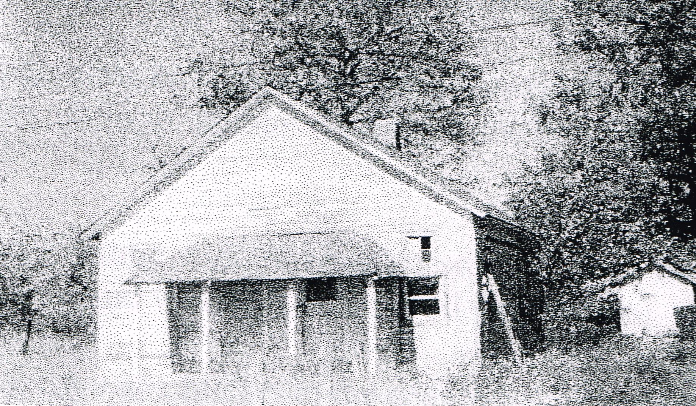
Burnet School near Seymour, Missouri. Everett attended this country school for seven years. This picture was taken in 1974.

22

SCHOOL

School was a one room school house with eight grades. We walked a mile and a half each way to school. You started to school at age six. There was one teacher for eight grades. After eight grades you went to high school in Seymour.

At school we had a wood burning stove in the center of the room. Those close to the stove were warm, those away from it were cold.

We had homework and had to study. There was no question about it. And we did it, by coal oil lamp at that.

We had a water bucket in the coat closet. We went to the spring on a farm next to the school and carried drinking water for the day. Each child had his own cup. Later they drilled a well so we didn’t have to carry the water.

At recess and at the noon hour, we played marbles or had an old can which we hit with sticks, back and forth. What fun!

The day after Halloween we always had the front porch of school filled with fire wood. We had to clear it out before we could get into the school. The chimney would be filled with sacks.

When I was in the eighth grade, we moved to another farm three miles north of Seymour. I attended Mt. Dale School. We had a softball team so we were happy about that. Every Friday afternoon we either traveled to another school or they came to ours for a game. We didn’t win many games, but we had a good time.
23

We only lived there for about a year. We moved to a farm three miles west of Seymour. I attended Seymour High School. My very best friend, Bill Kelly and I, went through twelve years of school together, except for the seven months I attended Mt. Dale. Bill and his brother were the ones who shared our club house.

In high school I was on the softball team, track team, debating team, and worked part-time in the library. I was senior class vice president. And, oh yes, cheer leader for the basketball team.

Just after I started high school, some of the older students organized a sit down strike. We had a study hall where everyone gathered first thing in the morning and from there we went to different classes. This particular morning the bell rang to go to class and everyone just sat there. The bell rang again and everyone just sat there. After three bells, the superintendent came in and said OK. So we sat in the study hall all day. End of strike.

After graduating from high school (I was third in a class of 40), I wanted to attend trade school. In those days you could take a teachers exam, go to college that summer and teach in the fall. I did take and pass the teachers exam, but I was unable to get a school, so that was that.

There was no such thing as a student loan in those days. I wanted to go to college, but there was no way, just no way. So I joined the Citizens Conservation Corps (CCC).

The CCC was a government program designed during the depression years, to give young guys something to do. The main reason I joined was I wanted to be sent out of state, but they didn’t do that any more.
24

So I went to Stone County, Shell Knob, where we worked on roads. It wasn’t long until they sent me to Willow Springs. Then we worked in the Mark Twain National Forest planting trees. Soon after that I was transferred to Springfield. Then I got a job working in the lumber yard in Seymour and was discharged from the CCC.

While I was in the CCC, I got paid $30 a month plus room, board, and clothing. That was pretty good. They sent $22 out of the $30 to our homes and gave us $8. My parents saved the money sent to them and gave it to me when I returned.

They gave us a limited amount of military training in the CCC camps.

CHURCH

We didn’t have a church in our community, but mother always taught us about Jesus. At times, a visiting preacher would come to our school house for services. In later years we had regular church services in our school--Free Will Baptist.

I remember one time that we went to church on a Saturday night. My mother went forward to accept Christ as her savior. The women told her, “we were surprised to see you go forward.” They thought she was already a Christian because she was such a good person. But Mom knew being a good person would not save you. The next morning, we walked one and half miles to church.

While living on the farm north of Seymour, they had a revival in the Presbyterian Church. One night several of us boys went forward and accepted Jesus as our Savior. I have never been sorry about that.

25

While working in the lumberyard at Seymour, I saw two men come in. They were building something and bought what lumber they needed there. I knew one of the men, Elmer Joiner. I remember him playing sand lot baseball in earlier years. He was a brawler and a drinker (tough). I thought those two were the happiest men I had ever seen. One day I asked the manager who that man with Elmer Joiner was. He said he is the preacher at that Pentecostal Church. Well that ruined an idea I had about Pentecostal people. They were not weird after all. If someone could cause Elmer Joiner to change there had to be something there.

A few days later, my mother wanted to go to the Pentecostal Church, so I took her. The house was packed. I liked what I saw and I continued going there. Sometime later, I received the baptism of the Holy Spirit. From then on I was a full-fledged Pentecostal.

After we went to California we attended Faith Assembly of God Church in Pomona. I served on the church board, was church treasurer, led the youth, and taught Sunday School. Later, in 1975, we bought our first home in Chino. Then we started attending Bethel Tabernacle in Ontario which was closer to home. At Bethel Tabernacle, I served on the church board and taught Sunday School.

26

YOUTHFUL ADVENTURES

My brother and I, along with two brothers who lived close to us, decided to build a clubhouse. We went into the woods and found some small saplings. We bent them over and found some heavy cardboard and lined them with it. We had a clubhouse. The other boys had an older brother at home so one day they found a whiskey bottle with just a little left in it. We left it in our clubhouse in case of snake bites. One day, Dad came to take a look at our clubhouse. He found the whiskey bottle. Needless to say that was the last of our clubhouse.

When I was about six or seven years old, we had a dog. We were playing with him one day When he began to act strange. My mother looked outside and saw him and told us to run to the granary (a place where we stored grain). We ran, but one of us ran to the field to get dad. By that time the dog had crawled under the granary. They shot him and discovered that he was in the last stages of rabies. Only by God’s grace were we not bitten.

Another time dad was raking hay in the meadow, I was probably five or six. I was following where the rake wheels mashed the windrow down, when I stepped into a bumble bees nest. You talk about pain and sickness. I vomited for hours.

When I was in my teens, we went to a shivaree for a couple. The older boys were smoking cigars, so I thought I could too. We rode in the back of a stake bed truck and by the time I got home, about 2 miles, I was s-i-c-k, s-i-c-k. I vomited like you wouldn’t believe. I turned dead pale. The next morning I still wasn’t feeling well. My mother asked one of my brothers what was wrong with me. I think she knew. That was the end of my smoking days.

27

DIFFICULT TIMES

One winter, I don’t recall the year, we had a smallpox epidemic. You talk aboutsick, we all were, but we recovered. Many people died because of it. We had a neighbor who came to our place every morning and afternoon to do our chores.

At that time, a dozen eggs would bring ten to fifteen cents a dozen. Wages for a man was $1.00 a day. When I was a teenager, I worked for my grandpa for .75 cents a day. Your could buy a 12 oz. bottle of pop for five cents and a loaf of bread for a dime, if you had it.

In 1929, the stock market collapsed. It didn’t affect us that much, but four years later, when all the banks closed, it did. Those who had money lost it.

Then we had about four years of drought. Nobody raised much of anything. Soup lines formed in the cities. Men fought each other for the contents of a garbage can. Farmers cut the lower limbs off trees for the cattle to eat.

The Government built canneries over the country and bought cattle. Local people canned the meat and shipped it to the city soup kitchens. It helped everyone.

We were fortunate to live in the country. At least we grew a few things. I can never remember going hungry.

28

My Dad told me about the time he was walking to the general store to get a 25 lb. sack of flour. It cost $1.00. He had nine rabbits to sell at ten cents each. That made a total of ninety cents. On the way he saw a live rabbit. He picked up a rock and threw it and he now had ten rabbits for a total of $1.00.

I don’t recall the exact year, but it was in the early 1930's, in the summer, when the grasshoppers came by the thousands. So many, it darkened the sun. They would land in a corn field and in no time nothing was left.

You will have to judge for yourself whether this is true or not, but I was told that a farmer planted a field of popcorn. I think it was in the 1930‘s. One hot, very hot, day he was down in the corn field plowing. He stopped for a while and went down to the spring for a drink of water. When he returned the popcorn had popped. The mule thought it was snowing and froze to death.

About this same time, a farmer was plowing a field. He stopped for a while and went to get a drink. When he returned, grasshoppers had devoured his horses and were pitching horseshoes.

FUN TIMES

Every Fourth of July we went to what we called the Diggins Picnic. Folks for miles around would gather in Diggins (four miles north of our place) and had a big time. There were games, ice cream cones (5 cents) and sometimes a movie. We had a ball. We had to wait until after dark to do our chores.

29
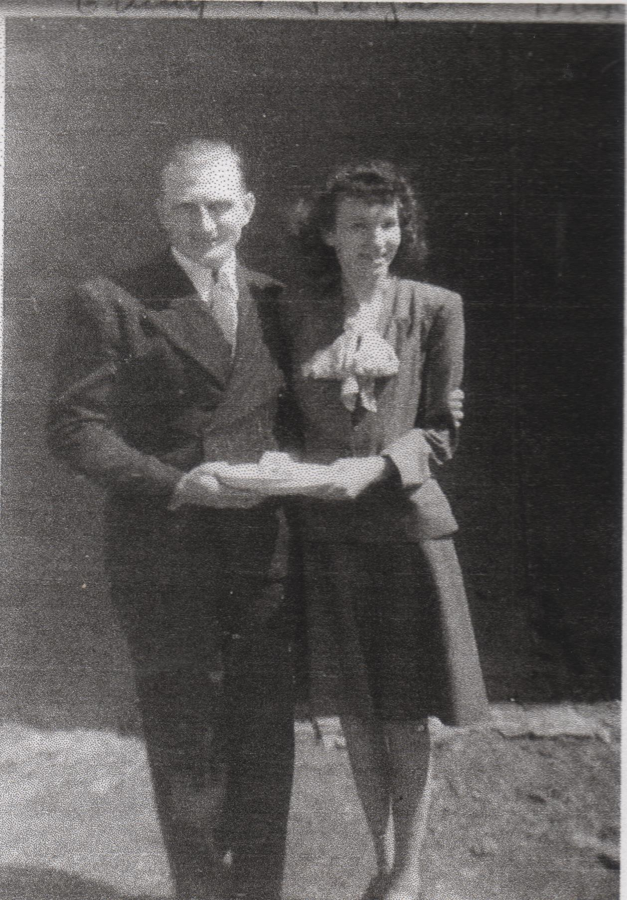
FLOYDENE

I saw a young lady at church and I thought, “WOW!” I had never really had a girlfriend. I asked another young man who that girl was and he said, “Brother [Claus] Daniel’s daughter, pastor of the church.” The rest is history. I fell head over heels in love. God was directing me in the right direction.

Floydene and I dated often until September 1, 1942, when we were married. Our courtship wasn’t complicated. There wasn’t much to do in Seymour. I didn’t have a car, so we walked down town and talked. We had ice cream, cold drinks, or something like that. We just enjoyed being together. By this time, I had quit work at the lumberyard and was working at the Missouri Farm Association (MFA) store.

OUR CHILDREN

Our girls were very obedient. We brought them up to love the Lord and they never caused us any trouble. We always took them to Sunday School and church. When they were small, getting them ready was something else. You might say we had an assembly line. One of us bathing, the other fixing hair and dressing.

Our first child Gary Dean was stillborn while I was in South Carolina (1942). Glenda Kay was born in 1944 in Seymour. Janice Ann in 1946 in Seymour. Charlotte Fay in 1948 in Oroville, California. And Phyllis Diane was born in 1950 in Pomona, California.

When Phyllis was born, Floydene had a real hard time. We almost lost her. The next morning, the nurse brought into the room a red headed baby boy. Mistake! His last name was Parker.
30

She worried about keeping the baby’s formula fresh in an ice box. We didn’t have a refrigerator. You couldn’t find one right after the war. One day I was in Pomona and went into McMahans Furniture Store. They had one and I bought it. I didn’t tell her about it so when she got home from the hospital it was a good surprise.
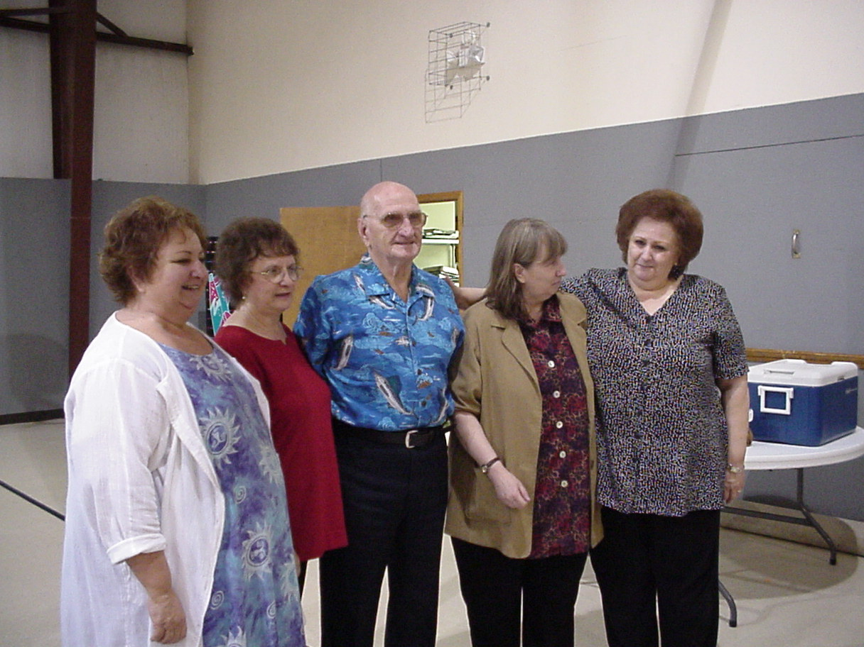
We bought our first TV in 1951. You could look into the room and see four sets of eyes fixed on the screen. Never a movement from them.

They have all grown up now and have families of their own, except for Phyllis. She never married.

Our oldest daughter, Glenda Kay, was active in Girl Scouts and was on the high school drill team She just recently retired and is living in Corona, California.

Janice lives in Nixa with her husband Alex Trout.

Charlotte married Charles Hopkins. They had been married almost forty years when she passed away in March 2007. Charles, you will always be a member of this family.

Phyllis worked for 21 years at Potlatch Forests in Pomona. She now works for the San Bernardino, California School District.

31

I have eight grandchildren and twelve great grandchildren. We love you very much. We are proud of you. God bless all of you.

DANIEL FAMILY

My story would not be complete without saying a few things about Floydene’s family. Her father was Claus Daniel. He was always called “Cluris” by those who knew him. We don’t know where that pronunciation came from.

Floydene’s mother was Faye Maples. They were neighbors of the Bradford family. Faye and Cleo Maples (Juanita’s mother), were sisters.

Jack Daniel, Cluris’ father, was a Justice of the Peace in Stone County. He officiated in the marriage of Faye and Claus and Freddie and Cleo. But since he was JP in Stone County and the Maples and Bradfords lived in Christian County, they had to go into Stone County for him to perform the ceremony. The two couples drove over in a buggy to where Jack Daniel was building a house. The house was in Christian County, just outside his jurisdiction. So they had to drive the buggy across the road into Stone County for the marriage to be official.

Claus and Faye Daniel and Freddie and Cleo Bradford were saved in a revival held by George Youngblood. I don’t know the exact year, but it was in the early 1930's. Wendell Daniel told me they rode home that night in a stake bed truck. He said his dad (Claus) preached on his way home.

Claus was a farmer, but the call to preach was very strong. In 1934, the crops all dried up. He told me that God was dealing with him. God showed him the fire in hell, just like he was hanging on a wire over hell. It was then he began preaching. It was his way of life from then on.
32

Claus and Faye were like parents. They treated me like one of their own. Not a cross word in over forty years. They moved to Seymour in the late 1930's and began having church services in homes. Later they rented a building on the town square.

At that time, Seymour was a tough town. Many individuals were sent to prison for crimes committed in the area. There was a saloon on every corner of the square. After Claus came to town, they all closed down except one. It finally had to close. The mayor told Claus, “You have done more for this town than anyone.”

Claus was ministering at a church in Hartsville, Missouri when he died. Just a week before he had held a revival.

Floyd Herman Maples, brother of Robert Herschel, Zelma’s father, became a doctor. He delivered Floydene and she was named after him.

MILITARY DUTY

My three brothers had all volunteered for the Navy, but I waited until I was drafted, December 8, 1942. I was sent to Ft. Leavenworth, Kansas. Just before Christmas, we all got a three- day pass and I went home. We
hadn’t bought any gifts, but it was the best Christmas ever. I unexpectedly got to be home for Christmas.

33

After about a month in Ft. Leavenworth, I and about 200 other guys were shipped to Ft. Jackson, South Carolina. When we arrived I was amazed to find the toilets and drinking fountains at the train station all marked colored and white. I couldn’t believe it. The Civil War had been over for more than a hundred years, but not in the South.

We were assigned to a convalescent hospital; had basic training in South Carolina then went to Tennessee for a year.

While in Tennessee, Floydene came down and spent about six months. This was wonderful. After a year we headed back to South Carolina and prepared to go overseas. They sent us to a staging base in Pittsburgh, California then to New Guinea. From there to Leyte Island in the Philippines. We set up our hospital and remained there for the duration of the war.

There were not many Christians in the Army, but I became friends to five of them. Non-Christians were not against us and respected our stand.

Once we were without a Chaplain for a while. We had a public address system all over the hospital (3000 beds) with speakers mounted in palm trees. We were given permission to have Scripture reading (without comment) and prayer every morning. I don’t know how much good we did with this, but I do know it didn’t do any harm and up to 3000 heard the gospel every morning.

One day a man asked me why I prayed for our officers and government officials. I explained the Bible instructs us to do so. I was happy to know that he had heard and paid attention to what was said.

34

While we were in a ship convoy to the Philippines, we were attacked by Jap planes. They hit one ship, but not ours.

My three brothers were all on different ships. One time all their ships were in our area, I got a twenty-four hour pass and went to look for them You had to hitch a ride to the ship. From there, we went to another brother’s ship. My third brother’s ship had just left about 10 minutes earlier. So I just missed seeing all my brothers by 10 minutes.

My job was to check all the patients in when they came to the hospital. I checked their equipment and gave them a receipt. The day before they left, I had to check their medical records and return their equipment to them.

My best friend was a baker. I worked in a building with no windows so I could have a light on late at night. When my friend came over to write letters, he brought things such as pie and cake. WOW!

One night I had just gone to bed when someone knocked on my door, “Barker, get up. The war is over.” This was the day we all were waiting to hear.

Then I thought of the military cemetery, hundreds of little white crosses. These men would never go home.

Shortly our hospital outfit was disbanded and went to other units awaiting the trip home. We were scheduled to go home by length of service, length of service overseas, and your number of points. It wasn’t long before I was on my way. It took about thirty days to get to us.
35

We docked in San Pedro, California. We shipped to Riverside, then to Ft. Leavenworth, Kansas, for discharge. I arrived in Ft Leavenworth in early January 1946 and called home. Floydene ask, “Did you hear about your mother?” I said “no.” She said, “She passed away. The funeral is over. ” I remembered what a good Mama she always was and thought, “I could have written more often, but it’s too late.” If anyone ever went to heaven, my mother is there. I think many times how she must have agonized in prayer for her four boys; all in war at the same time.

POST WORLD WAR II

After the war Seymour was about the same, just a little country town. I worked for an apple grower for a time. Then in 1947, Floydene’s cousin, Blanche and her husband James Harris, his dad and sister, Gladys, came to Seymour from California and had a tent meeting. James and Blanche stayed with us while they were here. We got to talking aboutCalifornia and they wanted us to move there. We talked about it and decided to go. In the summer of 1947, we took our two little daughters, got on a bus, and moved to Pomona.

We arrived in Pomona on Wednesday and I went to work the following Monday. Carl Eutsler gave me a job on a freight dock. I waited another month before we decided to move to northern California. Floydene’s father was then ministering at a church in Oroville, so we moved up there.

36

I worked in the lumber industry. After about a year, we decided to move back to Pomona because the work in Oroville was seasonal. By this time we had three girls.

I went to work for the freight company where I worked before going to Oroville. I worked for them until they cut back on the labor force.

I worked for Kaiser Steel in Fontana. They were building on to the plant so I worked construction for three months and was laid off. I had a wife and three daughters and this was not the kind of employment I wanted.

I looked around for a steady job. I was knocking on doors about opening time, not at noon. I went to A..M. Lewis, a wholesale grocery company, and applied. Just so happened they needed someone. I hired on at $1.00 per hour, but it was steady work. I decided this was for me, so I gave it all I had. I followed my own philosophy, “Whatever you do, do it well.” My initial salary was $83 for two weeks. They deducted $2.30 for taxes.

I liked my work and worked hard at it. The adding machine was manually operated. We had to write everything on an invoice with a lead pencil. Ball point pens were not around in 1949. We didn’t get cash registers until about 1980. We began using computers at corporate headquarters in 1984. We changed from writing everything with pencil and paper to computers after about thirty-five years.

About a year later, frozen foods were just getting started vegetables, fruit, and juice. No TV dinners or pies at that time.

37

The store manager was making $100 a week plus a percentage of net profit. I decided that is the job I want. I watched everything he did. If I didn’t understand, I asked questions about it. If he was doing something and I wasn’t busy, I would volunteer to do what he was doing. Nine months later he took a bigger store and recommended me for his job. Twenty years later he told me, “The thing I remember about you, you were a hard worker.”

I trained several men who became store managers in other cities. Among them were J.R Harris and Lewis Waldrep.

I liked my job and tried to do a good job. In 1975 an opening came up for a supervisor job and I got it. I had eleven stores from El Centro, California to Las Vegas, Nevada. About a year later, they leased a car for me. I drove about 30,000 miles a year. If I was going very far, Floydene would go with me. Very nice.

One time I had to go to Pittsburgh, Pennsylvania for a meeting. She went with me. We had to pay her way, but it was nice. We got acquainted with another Christian couple from Portland, Oregon and spent our evenings with them. We had a great time.

In 1983, my last full year of work, our company did $600,000,000 in sales.

I retired in September 1984, after 35 years with the company. We didn’t do much after I retired except keep the house going. We traveled some.
38
Five years after I retired, Floydene was diagnosed with a malignant brain tumor. Six months later she was gone. What a devastation. After forty-seven years of marriage, I was alone.

I took a job delivering flowers for a flower shop, just to keep busy. But there was always night when I was not busy and still alone. I decided I had to have a change. I packed my clothes and TV and moved to Missouri. My daughter Phyllis, still lived in our house, so I was not worried about that.

JUANITA

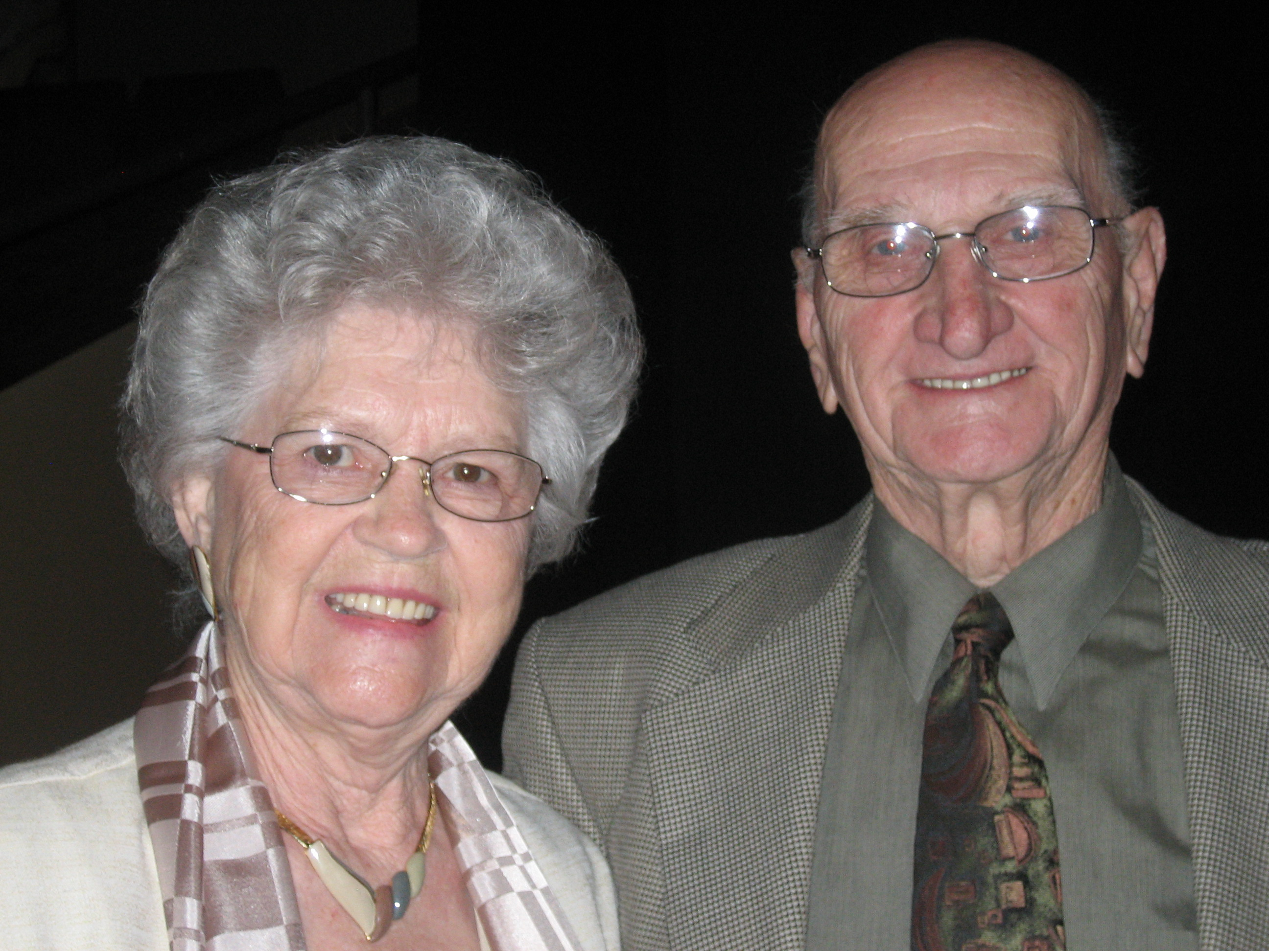
I took a job at Bass Pro Shops, but I was still lonely. One day, at a funeral, Earl Bradford asked me, “Do you have a friend?” I said, “Oh, yes. I have friends.” “No,” he said, “I mean A FRIEND.” I said, “No.” He said, “Call her,” pointing to Juanita. I hesitated for some time thinking nobody would want me. But finally I got up the nerve to call her. She said, “I will not see anyone until Orville has been gone for more than a year.” I said, “I respect you for that.”

I talked to each of my four daughters and told them I wanted to start seeing her. They agreed. When I told Charlotte who I was talking about, she said, “COOL!”

On our first date we went to my high school reunion in Seymour. This was the end of May 1993. We didn’t do a lot during our courtship days. We went out to eat. I helped her around her place mowing the lawn, etc. We enjoyed being together.

39

We decided to get married on her birthday, 1993. We wanted to get married with just a preacher and witnesses, but then we decided to be married at the Oak Ridge Church. Tim Snyder was the minister. Earl and Oleta were the witnesses.

When we arrived, Tim said, “We will have the ceremony in the parsonage.” That was OK. I thought he was taking a long time with the ceremony but didn’t suspect the surprise that was coming. When we came out of the parsonage, there before us were a whole bunch of people: my daughters, Juanita’s daughters, her sisters, Ward and Maxine Maples.

Ward was shooting a shot gun. And, they had me push Juanita around in a wheelbarrow. We looked at our car and it was full of inflated balloons. Then I remembered the Sunday before, Freda wanted to borrow my car. Said she hadn’t gotten her mother a birthday card. So she had a key made for my car. After all that we got into the car and started down the highway going to Big Cedar Lodge. I rolled down the windows and balloons floated out of the car.

We spent the weekend in the Branson area. Most of the shows were already closed, but we saw Andy Williams and Box Car Willie. After that we came to our home on Blackberry Lane in Nixa. We have lived here happily ever since. It has been a wonderful fifteen years.

Juanita’s daughters, Rita and Freda, live in Ozark with their husbands, Roger Fortner and Dale Rousell, respectively. She has four grandchildren and four great grandchildren.

40

God did me good when He gave me Juanita. She is a wonderful wife. Our families have blended together very well. I love her family and they love me. She loves my family and they love her. Of course, you must remember, my girls and Juanita are second cousins.

I have been sick for the last few months. Juanita has been super. She takes care of me perfectly, of course, she is PERFECT.

TRAVEL

At age 86, I have visited thirty-eight of the fifty states, plus Canada, Mexico, New Guinea, and the Philippines. Not bad for a man who never left Missouri until he was twenty years old.

We had a fifth wheel camper and a boat. They were a great source of enjoyment. A good part of the time we left them at Truman Lake. We fished a lot with friends and especially the Bradfords: Earl and Oleta, June and Junior, and Jack and Eva. Once, I caught a 29 lb. catfish. I think it was a record for our group.

For several years, we made trips to Casa Grande, Arizona with our group. We stayed each time for about 2 months.

That is about it for my personal recollections. The remainder of the story is information gathered during genealogical research. Remember, this part of my story is a work in progress. It is not complete or totally accurate, but it the best information we have to date. If you find errors or can provide more information, please contact the publisher so that it can be entered into the Barker database.

41

PART THREE
Related Families
John Wingo
Charles W. Silvey
Andrew Jackson Daniel

42

Decendants of John Wingo
Generation No. 1

1. John 1 Wingo was born 1844 in Virginia, and died 1929 in Webster County, Missouri 1. He married Anna Eliza Sneuter. She was born 1850 in Missouri, and died 1930 in Webster County, Missouri 1.

Children of John Wingo and Anna Sneuter are:
i. Dora Wingo 2, born about 1865, Missouri 2.
ii. Nannie Wingo, born about 1867, Missouri.
iii. Annie B. Wingo born about 1873, Missouri.
iv. Etha Wingo, born about 1879, Missouri.
v. Nellie Jane Wingo, born 01 June 1880, Missouri.

Generation No. 2

2. Nellie Jane 2 Wingo (John 1) was born 01 Jun 1880 in Missouri 3. She married William Elkaney Barker 01 Dec 1895 in Webster County, Missouri 4, son of John Barker and Rebecca Barker. He was born 26 Nov 1876 in Horse Cave, Hart County, Kentucky 5, and died 26 Apr 1950 in Carthage, Jasper County, Missouri 5.
NOTE: The children of Nellie Jane Wingo and William Elkaney Barker and their descendants are recorded elsewhere.

43

Endnotes
- USGenweb: Missouri, Webster County, Mt. Pisgah Cem.
- U.S. Census, 1880 Livingston County, Missouri Census.
- 1900 U.S. Census Webster County, Missouri.
- Ancestry.com, Missouri Marriages 1805-2002.
- Missouri State Archives.

44

Kinship of John Wingo

Name Relationship with John Wingo

Barker, CarrieGranddaughter
Barker, Doris Granddaughter
Barker, Edna Granddaughter
Barker, Ray T. Grandson
Barker, Thelma Granddaughter
Barker, William Elkaney Son-in-law
Barker, Yvonne Granddaughter
Carter, Jay T. Husband of the granddaughter Cornelison, Anna L. Great-granddaughter Cornelison, Edna O. Great-granddaughter Cornelison, Esther O. Great-granddaughter Cornelison, Fred K. Husband of the granddaughter Cornelison, Magdalene H. Great-granddaughter Cornelison, Raymond R. Great-grandson
Denney, Eugene Husband of the granddaughter Hubbard, Herschel G. Husband of granddaughter Sneuter, Anna Eliza Wife
Todd, Floyd J. Husband of the granddaughter
Todd, Maxine D. Great-granddaughter
Todd, Robert M. Great-grandson
Todd, Wanda E. Great-granddaughter
Wingo, Annie B. Daughter
Wingo, Dora Daughter
Wingo, Etha Daughter
Wingo, John Self
Wingo, Nannie Daughter
Wingo, Nellie Jane Daughter

45

Decendants of Charles Silvey

Generation No. 1

- Charles Silvey 1. He married Lutitia Howard 1.
Child of CharlesSilvey and LutitiaHoward is:

i. George Washington 2 Silvey, born 25 Feb 1826, Roane County, Tennessee; died 12 Mar 1897, Seymour, Webster County, Missouri.

Generation No. 2

- George Washington 2 Silvey (Charles 1) was born 25 Feb 1826 in Roane County, Tennessee 2, and died 12 Mar 1897 in Seymour, Webster County, Missouri 2. He married Minerva Jane Denney 11 Oct 1849 in Webster County, Missouri 3, daughter of Charles Denney and Annie Duncan. She was born 04 Sep 1832 in Wayne County, Kentucky 4, and died 18 Nov 1914 in Webster County, Missouri 4,5.

Children of GeorgeSilvey and MinervaDenney are:

3. i. CHARLES3 SILVEY, born 09 Aug 1850; died 09 Mar 1883.

4. ii. Smiley Silvey, born 12 May 1852, Missouri; died 18 Dec 1891, Webster County, Missouri.

iii. Letitia Ann "Tish" Silvey, born 07 Apr 1854, Missouri; died 10 Oct 1877; married Cornelius Loftin, 11 Aug 1872; born 1850.

46
5. iv. William C. Silvey, born 03 Aug 1856, Missouri; died 29 Jun 1923, Webster County, Missouri.

v. Sarah Catherine "Katy" Silvey, born 01 Sep 1858, Missouri; died 1924; married William Frank linWright; born 19 May 1857; died 18 Apr 1938.

6. vi. Jackson Silvey, born 25 Nov 1860, Missouri; died 09 Oct 1949, Seymour, Webster County, Missouri.

vii. George W. Silvey, born 06 Jun 1863, Missouri 6; died 25 May 1888, Seymour, Webster County, Missouri 6; married Linda Hines.

7. viii. Zerilda Silvey, born 16 Jun 1865, Missouri; died 30 Oct 1933, Webster County, Missouri.

ix. James M. "Jim" Silvey, born 25 Jun 1867, Missouri 6; died 18 Jan 1942, Seymour, Webster County, Missouri 6; married Emma I.-?-; b. Mar 1874.

x. Susan Silvey, born about 1870, Missouri; married John Wright.

xi. Elizabeth Silvey, born about 1872, Missouri.

8. xii. Thomas Silvey, born 28 Oct 1873, Missouri; died 30 Dec 1949, Webster County, Missouri.

Generation No. 3
- Charles Silvey 3 (George Washington 2, Charles 1) was born 09 Aug 1850, and died 09 Mar 1883. He married Sarah Ann Loftin 06 May 1869. She was born 1848 in North Carolina.
47

Children of Charles Silveyand Sarah Loftin are:
i. Minerva Jane 4 Silvey, born 1874; died 1934.
9. ii. William Clint Silvey, born 22 Jan 1874; died 01 May 1936, Nevada, Vernon County, Missouri.
4. Smiley 3 Silvey (George Washington 2, Charles 1) was born 12 May 1852 in Missouri 6, and died 18 Dec 1891 in Webster County, Missouri 6. He married Joyce Ellen Wright 18 Jan 1872 in Webster County, Missouri 7, daughter of Burgess Wright and Rachel Goss. She was born 01 Jun 1851 in North Carolina, and died 03 Jul 1939.

Children of SmileySilveyand JoyceWright are:

10. i. William Franklin 4 Silvey, born 28 Oct 1872, Webster County, Missouri; died 22 Apr 1972, Webster County, Missouri.

ii. Jerry B. Silvey, born 1874, Missouri 8; died 1954, Seymour, Webster County, Missouri 8; married Cynia Roland.

iii. Idela J.Silvey, born about 1876, Missouri.

11. iv.Mary C.Silvey, born 06 Sep 1878, Missouri; died 14 Jan 1968.
5. William C. 3 Silvey (George Washington 2, Charles 1) was born 03 Aug 1856 in Missouri 8, and died 29 Jun 1923 in Webster County, Missouri 8, 9. He married (1) -?-Silvey. He married (2) Mary Ann Hargus. She was born 15 Sep 1855, and died 10 Jan 1886. He married (3) Clara Hargus.
48

Children of WilliamSilveyand MaryHargus are:

i. Jackie4Silvey, born after 1880; died Webster County, Missouri.

ii. IdaSilvey, born 01 Dec 1881; married John Ragsdale.

12. iii. Mary JaneSilvey, born 31 May 1884; died 14 Aug 1958.
6. Jackson 3 Silvey (George Washington 2, Charles 1) was born 25 Nov 1860 in Missouri 10, and died 09 Oct 1949 in Seymour, Webster County, Missouri 10,11. He married Rebecca Ann Embrey 02 Dec 1885 in Webster County, Missouri 12, daughter of John Embrey and Mary Johnston. She was born 14 Mar 1868 in Missouri 13, and died 03 Mar 1930 in Webster County, Missouri 13,14.

Children of Jackson Silvey and Rebecca Embrey are:

13. i. Charles F. 4 Silvey, born 24 Sep 1886, Missouri; died 05 Oct 1972, Seymour, Webster County, Missouri.

ii. John Washington "Red John" Silvey, born 26 Jan 1888, Taney County, Missouri15; died 14 Sep 1961, Douglas County, Missouri; married (1) Francis J. Taylor; born 21 Dec 1888; died 13 Apr 1921; married (2) Verba J.Wingo, 14 Jun 1925, Webster County, Missouri16; born 28 Jul 1898; died 08 Jul 1981, Douglas County, Missouri.

49

iii. Ethel F. Silvey, born Dec 1889, Missouri.

iv. James Lloyd Silvey, born 15 Dec 1894, Missouri1 7; died 11 Jan 1982, Seymour, Webster County, Missouri 17; married Florine Johns, 10 Jan 1915; born 13 Feb 1896, Christian County, Missouri17; died 31 Dec 1988, Seymour, Webster County, Missouri 17.

14. v. Luther B. Silvey, born 14 Jan 1900, Missouri; died 14 Oct 1983, Seymour, Webster County, Missouri.

7. Zerilda 3 Silvey (George Washington 2, Charles 1) was born 16 Jun 1865 in Missouri, and died 30 Oct 1933 in Webster County, Missouri. She married Elliott Gaines Denney 10 Feb 1884 in Webster County, Missouri 18, son of Judge Denney and Kiziah Cardwell. He was born Abt. 1857, and died 1939.
Child of Zerilda Silvey Elliott is:
15. i. Lucy 4 Denney, born 1895; died 1976
8. Thomas 3 Silvey (George Washington 2, Charles 1) was born 28 Oct 1873 in Missouri 19, and died 30 Dec 1949 in Webster County, Missouri 19. He married Hannah Clark.
Child of Thomas Silvey and Hannah Clark is:
i. Clella Mae 4 Silvey.

50

Generation No. 4

9. William Clint 4 Silvey (Charles 3, George Washington 2, Charles 1) was born 22 Jan 1874, and died 01 May 1936 in Nevada, Vernon Count, Missouri. He married (1) Molly "Mary" Burks. He married (2) Melvina Jane Hooten. She was born 22 Jun 1887, and died 26 Dec 1977 in Webster County, Missouri.

Child of WilliamSilvey and MelvinaHooten is:

i. Perry Jackson 5 Silvey, born 18 Sep 1927; married (1) Opal Talmage Parsons; born 24 Sep 1928 married (2) Linda Nedan Kareff; born. 27 Jun 1945.
10. William Franklin 4 Silvey (Smiley 3, George Washington 2, Charles 1) was born 28 Oct 1872 in Webster County, Missouri 19, and died 22 Apr 1972 in Webster County, Missouri 19,20. He married Lucinda Kathrine Cardwell 26 Nov 1892 in Webster County, Missouri 21, daughter of Zachery Cardwell and Amelia Jones. She was born 17 Jul 1871 in Webster County, Missouri 22,23, and died 08 Oct 1937 in Webster County, Missouri 24,25.
Children of William Silvey and Lucinda Cardwell are:

i. Wilson 5 Silvey, born 11 Jan 1894, Webster County, Missouri 26; died 11 Jan 1993, Riverside County, California 26; married Ressie Odena Cousins, 1920, Webster County, Missouri; born 01 May 1904, Missouri 27; died 19 Feb 1997, Banning, Riverside County, California 27,28.

51

16. ii. Sherman Silvey, born 12 Jun 1894, Seymour, Webster County, Missouri; died 12 Sep 1991.

17. iii. Mable Silvey, born 08 Mar 1897, Seymour, Webster County, Missouri; died 24 Dec 1945, Seymour, Webster County, Missouri.

iv. Fannie Silvey, born 25 May 1900, Seymour, Webster County, Missouri; married Granvil Helms , 04 Aug 1915, Seymour, Webster County, Missouri 29.

v. Bert Silvey, born 11 May 1907, Webster County, Missouri 30; died May 1984, Essex, Iowa 30.

vi. Celella Silvey, born 25 Feb 1904, Seymour, Webster County, Missouri; died 15 Sep 1935; married (1) Vernon Cardwell; married (2) Mckinley Denney.

vii. Ada Silvey, born 18 Oct 1906, Webster County, Missouri 30; died 11 Jul 1987, Seymour, Webster County, Missouri 30; married Cecil Wingo, 25 Feb 1923, Webster County, Missouri 31; born 12 Mar 1902 32; died 27 Mar 1984, Seymour, Webster County, Missouri 32.

viii. Beulah Silvey, born 10 Mar 1909, Webster County, Missouri 32; died 01 Jul 2005, Seymour, Webster County, Missouri 32; married Albert Fann 33; born 05 Mar 1899 34; died Dec 1984, Springfield, Greene County, Missouri 34.

ix. Zula Silvey, born 10 Mar 1909, Webster County, Missouri; died 1954.

x. Marie Silvey, born about 1916, Webster County, Missouri.

52

xi. Ada Silvey, married CECIL WINGO; born 12 Mar 1902 34; died 27 Mar 1984, Seymour, Webster County, Missouri 34.

11. Mary C. 4 Silvey (Smiley 3, George Washington 2, Charles 1) was born 06 Sep 1878 in Missouri, and died 14 Jan 1968. She married James O.Brixey.
Children of Mary Silvey and James Brixey are:

i. Harry M.5 Brixey, born 06 Aug 1895; died 09 Jun 1991; married Myrtle Burks.

ii. Everett Brixey, born about 1900.

iii. Zella Brixey, born about 1902.

iv. Emerson Brixey, born about 1909.

12. Mary Jane 4 Silvey (William C.3, George Washington 2, Charles 1) was born 31 May 1884, and died 14 Aug 1958. She married Lee Andrew Wingo. He was born 1875, and died 1952 in Webster County, Missouri.
Children of MarySilveyand LeeWingo are:

i. Louie 5 Wingo.

ii. Loren Wingo, born about 1920; died 09 Aug 1997.

iii. Lorene Wingo, born about 1920; died 29 Feb 2000; married (1) Clarence Cummins; married (2) AudieTurner.

iv. Clarence Wingo, born 07 Oct 1907; died 10 Jan 1976, Wright County, Missouri; married Nellie Plaster; born 16 Mar 1910; died 15 Mar 1998.

53
v. Leonard Samuel Wingo, born 08 Apr 1911; died 04 Nov 1993.

vi. Nerly Ann Wingo, born 08 Apr 1911; died 01 Oct 1927.

13. Charles F. 4 Silvey (Jackson 3, George Washington 2, Charles 1) was born 24 Sep 1886 in Missouri 35, and died 05 Oct 1972 in Seymour, Webster County, Missouri 35,36. He married Maggie May Boring. She was born 11 Nov 1893 in Washington County, Missouri 37, and died 14 Apr 1983 in Seymour, Webster County, Missouri 37.

Child of Charles Silvey and Maggie Boring is:

i. Irene 5 Silvey, born 14 Jun 1914; died 08 Oct 1975; married Eli Glen Cardwell; born 1906; died 27 Jun 1987.

14. Luther B. 4 Silvey (Jackson 3, George Washington 2, Charles 1) was born 14 Jan 1900 in Missouri 37, and died 14 Oct 1983 in Seymour, Webster County, Missouri 37,38. He married Opha Painter. She was born 16 Dec 1904, and died Oct 1991.
Children of Luther Silveyand Opha Painter are:

i. Luther Doyle 5 Silvey, born about 1928; married LoisMorris.

ii. Marvin A. Silvey, born about 1932.

54

iii. Norma Jean Silvey, born about 1936; married Bob Porter.

15. Lucy 4 Denney (Zerilda 3 Silvey, George Washington 2, Charles 1) was born 1895, and died 1976. She married Jeff Matney.
Children of Lucy Denney and Jeff Matney are:
i. Pauline 5 Matney, born about 1912.
ii. Irene Matney, born about 1913.
iii. Elliot Matney.
Generation No. 5
16. Sherman 5 Silvey (William Franklin 4, Smiley 3, George Washington 2, Charles 1) was born 12 Jun 1894 in Seymour, Webster County, Missouri 38, and died 12 Sep 1991 38. He married The lma McKiddy 15 Apr 1932 in Webster County, Missouri 39. She was born 29 Apr 1902 in Seymour, Webster County, Missouri 40, and died Mar 1992 in Howell County, Missouri 40.
Child of ShermanSilvey and ThelmaMcKiddy is:

i. Cecil Bernard 6 Silvey, born 08 Jan 1929, Seymour, Webster County, Missouri; died 19 Nov 1969.
17. Mable 5 Silvey (William Franklin 4, Smiley 3, George Washington 2, Charles 1) was born 08 Mar 1897 in Seymour, Webster
55

County, Missouri 41, and died 24 Dec 1945 in Seymour, Webster County, Missouri 41,42. She married Roy Elmer Barker 01 Dec 1917 in Seymour, Webster County, Missouri 43, son of William Barker and Nellie Wingo. He was born 26 Nov 1896 in Webster County, Missouri 44,45, and died 21 Nov 1986 in Seymour, Webster County, Missouri 46,47.
Children of Mable Silvey and Roy Barker are:

18. i. Donald Eugene 6 Barker, born 19 Oct 1918, Seymour, Webster County, Missouri; died 13 Sep 2002, Webster County, Missouri.

ii. William HowardBarker, born 1920, Seymour, Webster County, Missouri; married Billie Jean A lexander, 11 Oct 1941, Webster County, Missouri 48; born 10 Jun 1925, Webster County, Missouri 49.

19. iii. EverettBarker, born 13 Jun 1922, Seymour, Webster County, Missouri.

iv. Wayne DavidBarker, born 1924, Seymour, Webster County, Missouri; married MollieBlanken ship; born Webster County, Missouri.

20. v. AnnabelleBarker, born 09 May 1933, Seymour, Webster County, Missouri; died 14 Mar 2006, Springfield, Greene County, Missouri.
Generation No. 6
18. Donald Eugene 6 Barker (Mable 5 Silvey, William Franklin 4, Smiley 3, George Washington 2 , Charles 1) was born 19 Oct 1918 in Seymour, Webster County, Missouri 49,50, and died 13 Sep 2002 in Webster County, Missouri 51,52. He married Mildred E. Nadine"Pruett 03 Feb 1947 in Webster County, Missouri 52. She was born 26 Jan 1921 in Webster County, Missouri 53.

56

Children of Donald Barker and Mildred Pruett are:

i. Violet Kay 7 Barker, born Webster County, Missouri; married OtisVan Stinnett, 17 Mar 1967, Webster County, Missouri 54.

ii. Diana Barker, born Webster County, Missouri; married James E.Bowers, 17 Jan 1969, Seymour, Webster County, Missouri 54.
19. Everett 6 Barker (Mable 5 Silvey, William Franklin 4, Smiley 3, George Washington 2, Charles 1) was born 13 Jun 1922 in Seymour, Webster County, Missouri 55. He married (1) Floydene Daniel 01 Sep 1942 in Seymour, Webster County, Missouri 55,56, daughter of Claus Daniel and Zelm a Faye Maples. Floydene was born 02 Nov 1925 in Stone County, Missouri57, and died 03 Aug 1989 in Chino, San Bernadino County, California 57,58. He married (2) Juanita Mae Bradford 22 Nov 1993 in Walnut Shade, Taney County, Missouri 59. She was born 22 Nov 1928 in Ponce de Leon, Stone County, Missouri 60.

Children of Everett Barker and Floydene Daniel are:

i. Glenda Kay 7 Barker, born 30 May 1944, Seymour, Webster County, Missouri; married Lynden Dowdle, 21 Jun 1966 61.

ii. Charlotte Faye Barker, born 25 Mar 1948, Oroville, Butte County, California; died 03 Mar 2007, Springfield, Greene County, Missouri; married Charles Hopkins, 05 Oct 1968, Pomona, Los Angeles County, California 61.

57

iii. Phyllis Diane Barker, born 27 Mar 1959, Pomona, Los Angeles County, California.

iv. Janice Ann Barker, born 08 Sep 1946, Seymour, Webster County, Missouri; married (1) Paul Sutcliffe, 30 May 1964, Pomona, Los Angeles County, California 61; married (2) Ralph Troutt, 01 Sep 1977, Pomona, Los Angeles County, California 61; born about 1942.
20. Annabelle 6 Barker (Mable 5 Silvey, William Franklin 4, Smiley 3, George Washington 2, Charles 1) was born 09 May 1933 in Seymour, Webster County, Missouri 62, and died 14 Mar 2006 in Springfield, Greene County, Missouri 62. She married William"Willie" Ashley,Jr. 17 Feb 1951 in Webster County, Missouri 63. He was born 20 Mar 1925 in Misssouri 64, and died 19 Oct 1994 in Seymour, Webster, Missouri 64.

Children of Annabelle Barker and William Ashley are:

i. Janet 7 Ashley, born Missouri; married Kenneth Samuel Lovelace, 05 May 1973, Seymour, Webster County, Missouri 65.

ii. Bob Ashley, born Missouri; married Donna -?-

iii. Jim Sshley, born Missouri; married Sandy -?-

58

1. The Goodspeed Publishing Company, History of Laclede, Camden, Dallas, Webster, Wright, Texas, Pulaski, Phelps and Dent Counties, Missouri, 1889.
Endnotes
2. Findagrave.com

3. The Goodspeed Publishing Company, History of Laclede, Camden, Dallas, Webster, Wright, Texas, Pulaski, Phelps and Dent Counties, Missouri, 1889.
4. Findagrave.com

5. Missouri State Archives, Certificate #37773.

6. Findagrave.com

7. Ancestry.com, Missouri Marriages 1805-2002.

8. Findagrave.com

9. Missouri State Archives, Death Certificate 20650.

10. Findagrave.com

11. Missouri State Archives, Missouri Death Certificates 1910-1957. Certificate #36317.

12. Ancestry.com, Missouri Marriages 1805-2002.

13. Findagrave.com

14. Missouri State Archives, Missouri Death Certificate #11513.

15. World War One Draft Registrations.

16. Ancestry.com, Missouri Marriages 1805-2002.

17. Findagrave.com

18. Ancestry.com, Missouri Marriages 1805-2002.

19. Findagrave.com

20. U.S. Social Security Death Index.

21. Ancestry.com, Missouri Marriages 1805-2002.
59

22. WorldConnect Project - Some Descendants of Richard Gaines of Old Rappahannock County, Virginia - The First Nine Generations.

23. Findagrave.com

24. WorldConnect Project - Some Descendants of Richard Gaines of Old Rappahannock County, Virginia - The First Nine Generations.

25. Findagrave.com

26. California Death Records 1940-1997.

27. U.S. Social Security Death Index.

28. California Death Records 1940-1997.

29. Ancestry.com, Missouri Marriages 1805-2002.

30. U.S. Social Security Death Index.

31. Ancestry.com, Missouri Marriage Records 1805-1925.

32. U.S. Social Security Death Index.

33. Ancestry.com, Missouri Marriage Records 1805-2002.

34. U.S. Social Security Death Index.

35. Findagrave.com

36. U.S. Social Security Death Index.

37. Findagrave.com

38. U.S. Social Security Death Index.

39. Ancestry.com, Missouri Marriages 1805-2002.

40. U.S. Social Security Death Index.

41. Findagrave.com

42. Missouri State Archives, Certificate #42785 .

60
43. Ancestry.com, Missouri Marriages 1805-2002.

44. U.S. Social Security Death Index.

45. Findagrave.com

46. U.S. Social Security Death Index.

47. Findagrave.com

48. Ancestry.com, Missouri Marriages 1805-2002.

49. U.S. Social Security Death Index.

50. Findagrave.com

51. U.S. Social Security Death Index.

52. Findagrave.com

53. U.S. Social Security Death Index.

54. Ancestry.com, Missouri Marriages 1805-2002.

55. Interview - Everett Barker - August 1, 1999.

56. Ancestry.com, Missouri Marriages 1805-2002.

57. U.S. Social Security Death Index.

58. California Death Records 1940-1997.

59. Correspondence - Juanita Mae Bradford/ Barker.

60. Correspondence - Juanita Mae Bradford/ Barker

61. Interview - Everett Barker - August 1, 1999.

62. U.S. Social Security Death Index.

63. Findagrave.com Obituary note added Apr 18 2008.

64. U.S. Social Security Death Index.

65.Ancestry.com Missouri Marriages 1805-2002.
61

Kinship of Charles Silvey

Name Relationship with Charles Silvey

-?-, Donna Wife of [Bob Ashley] the 4th great-grandson
-?-, Emma I. Wife of the grandson
-?-, SandyWife of [Jim Ashley] the 4th great-grandson
Alexander, Billie Jean Wife of the 3rd great-grandson
Ashley, Bob 4th great-grandson
Ashley, Janet 4th great-granddaughter
Ashley, Jim 4th great-grandson
Ashley, "Willie", Jr. Husband of the 3rd great-granddaughter
Barker, Annabelle 3rd great-granddaughter
Barker, Charlotte Faye 4th great-granddaughter
Barker, Diana4th great-granddaughter
Barker, Donald Eugene 3rd great-grandson
Barker, Everett 3rd great-grandson
Barker, Glenda Kay 4th great-granddaughter
Barker, Janice Ann 4th great-granddaughter
Barker, Phyllis Diane 4th great-granddaughter
Barker, Roy Elmer Husband of the 2nd great-granddaughter
Barker, Violet Kay 4th great-granddaughter
Barker, Wayne David3rd great-grandson
Barker, William Howard 3rd great-grandson
Blankenship, Mollie Wife of the 3rd great-grandson
Boring, Maggie May Wife of the great-grandson
Bowers, James E.Husband of the 4th great-granddaughter
Bradford, Juanita Mae Wife of the 3rd great-grandson
Brixey, Emerson 2nd great-grandson
Brixey, Everett 2nd great-grandson
Brixey, Harry M. 2nd great-grandson
Brixey, James O. Husband of the great-granddaughter

62

Brixey, Zella 2nd great-granddaughter
Burks, Molly "Mary" Wife of the great-grandson
Burks, MyrtleWife of the 2nd great-grandson
Cardwell, Eli Glen Husband of the 2nd great-granddaughter
Cardwell, Lucinda Kathrine Wife of the great-grandsonCardwell, VernonHusband of the 2nd
great-granddaughter
Clark, Hannah Wife of the grandson
Cousins, Ressie Odena Wife of the 2nd great-grandson
Cummins, Clarence Husband of the 2nd great-granddaughter
Daniel, Floydene Wife of the 3rd great-grandson
Daum, Grant 6th great-grandson
Daum, Randy Husband of the 5th great-granddaughter
Daum, Riley 6th great-grandson
Denney, Elliott Gaines Husband of the granddaughter
Denney, LucyGreat-granddaughter
Denney, McKinley Husband of the 2nd great-granddaughter
Denney, Minerva Jane Daughter-in-law
Dowdle, Lynden Husband of the 4th great-granddaughter
Dowdle, Michael Anthony 5th great-grandson
Dowdle, Patricia Ann 5th great-granddaughter
Embrey, Rebecca Ann Wife of the grandson
Fann, Albert Husband of the 2nd great-granddaughter
Fann, Albert Husband of the 2nd great-granddaughter
Gudea, -?-Husband of the 5th great-granddaughter
Gudea, Aaron6th great-grandson
Gudea, Daniel 6th great-grandson
Hargus, ClaraWife of the grandson
Hargus, Mary Ann Wife of the grandson
Helms, Granvil Husband of the 2nd great-granddaughterHines, Linda Wife of the grandson
Hommel, Kevin Husband of the 5th great-granddaughter
Hommel, Landon Allen 6th great-grandson

63

Hommel, Savanna Charlotte 6th great-granddaughter
Hooten, Melvina Jane Wife of the great-grandson
Hopkins, CharlesHusband of the 4th great-granddaughter
Hopkins, Jennifer Faye 5th great-granddaughter
Hopkins, Melissa Mae 5th great-granddaughter
Hopkins, Sandra Rae 5th great-granddaughter
Howard, Lutitia Wife
Johns, FlorineWife of the great-grandson
Kareff, Linda Nedan Wife of the 2nd great-grandson
Loftin, Cornelius Husband of the granddaughter
Loftin, Sarah AnnWife of the grandson
Lovelace, Josh 5th great-grandson
Lovelace, Kenneth Samuel h/o of the 4th great-granddaughter
Lovelace, Martin 5th great-grandson
Matney, Elliot2nd great-grandson
Matney, Irene 2nd great-granddaughter
Matney, Jeff Husband of the great-granddaughter
McKiddy, Thelma Wife of the 2nd great-grandson
Morris, Lois Wife of the 2nd great-grandson
Painter, Opha Wife of the great-grandson
Parsons, Opal Talmage Wife of the 2nd great-grandson
Peltepion, Khaji Husband of the 5th great-granddaughterPlaster, NellieWife of the 2nd great-
grandson
Porter, Bob Husband of the 2nd great-granddaughter
Pruett, Mildred E. "Nadine" Wife of the 3rd great-grandson
Ragsdale, John Husband of the great-granddaughter
Roland, CyniaWife of the great-grandson
Silvey, -?-Wife of the grandson
Silvey, Ada 2nd great-granddaughter
Silvey, Bert 2nd great-grandson
Silvey, Beulah 2nd great-granddaughter
Silvey, Cecil Bernard3rd great-grandson

64

Silvey, Celella 2nd great-granddaughter
Silvey, Charles Self
Silvey, Charles Grandson
Silvey, Charles F. Great-grandson
Silvey, Clella Mae Great-granddaughter
Silvey, Elizabeth Granddaughter
Silvey, Ethel F. Great-granddaughter
Silvey, Fannie2nd great-granddaughter
Silvey, George W. Grandson
Silvey, George Washington Son
Silvey, Ida Great-granddaughter
Silvey, Idela J. Great-granddaughter
Silvey, Irene 2nd great-granddaughter
Silvey, Jackie Great-grandson
Silvey, Jackson Grandson
Silvey, James Lloyd Great-grandson
Silvey, James M. "Jim" Grandson
Silvey, Jerry B. Great-grandson
Silvey, John Washington "Red John" Great-grandson
Silvey, Letitia Ann "Tish" Granddaughter
Silvey, Luther B. Great-grandson
Silvey, Luther Doyle 2nd great-grandson
Silvey, Mable2nd great-granddaughter
Silvey, Marie 2nd great-granddaughter
Silvey, Marvin A.2nd great-grandson
Silvey, Mary C. Great-granddaughter
Silvey, Mary Jane Great-granddaughter
Silvey, Minerva Jane Great-granddaughter
Silvey, Norma Jean 2nd great-granddaughter
Silvey, Perry Jackson 2nd great-grandson
Silvey, Sarah Catherine "Katy" Granddaughter
Silvey, Sherman 2nd great-grandson

65

Silvey, Smiley Grandson
Silvey, Susan Granddaughter
Silvey, Thomas Grandson
Silvey, William C. Grandson
Silvey, William ClintGreat-grandson
Silvey, William Franklin Great-grandson
Silvey, Wilson 2nd great-grandson
Silvey, Zerilda Granddaughter
Silvey, Zula 2nd great-granddaughter
Stanford, Christine 6th great-granddaughter
Stanford, Kathleen 6th great-granddaughter
Stanford, KenHusband of the 5th great-granddaughter
Stanford, Samuel 6th great-grandson
Sutcliffe, Julie 5th great-granddaughter
Sutcliffe, PaulEx-husband of the 4th great-granddaughter
Sutcliffe, Richard Lloyd 5th great-grandson
Taylor, Francis J. Wife of the great-grandson
Troutt, Ralph Husband of the 4th great-granddaughter
Turner, AudieHusband of the 2nd great-granddaughter
Van Stinnett, OtisHusband of the 4th great-granddaughter
Wingo, Cecil Husband of the 2nd great-granddaughter
Wingo, Clarence 2nd great-grandson
Wingo, Lee Andrew Husband of the great-granddaughter
Wingo, Leonard Samuel 2nd great-grandson
Wingo, Loren2nd great-grandson
Wingo, Lorene 2nd great-granddaughter
Wingo, Louie2nd great-grandson
Wingo, Nerly Ann 2nd great-granddaughter
Wingo, Verba J. Wife of the great-grandson
Wright, John Husband of the granddaughter
Wright, Joyce Ellen Wife of the grandson
Wright, William FranklinHusband of the granddaughter

66

Decendants of Andrew Jackson Daniel

Generation No. 1

1. Andrew Jackson 1 Daniel was born 27 Aug 1865 in Bradfeld, Stone County, Missouri1, and died 29 Apr 1945 in Ponce de Leon, Stone County, Missouri1. He married Mary Luthia "Bette" Benham/Ash.

Children of Andrew Daniel and Mary Benham are:

2. ` i. Claus Claud 2 Daniel, born 06 Oct 1903, Missouri; died Aug 1983, Monett, Barry County, Missouri.

3. ii. Leland Daniel, born about 1905, Missouri.
Generation No. 2
2. Claus Claud 2 Daniel (Andrew Jackson 1) was born 06 Oct 1903 in Missouri 2, and died Aug 1983 in Monett, Barry County, Missouri 2. He married Zelma Faye Maples. She was born 10 Oct 1906 in Clever, Christian County, Missouri 2, and died 18 Dec 1990 in Monett, Barry County Missouri 2.

Child of ClausDaniel and ZelmaMaples is:

i. Floydene 3 Daniel, born 02 Nov 1925, Stone County, Missouri 2; died 03 Aug 1989, Chino, San Bernadino County, California2,3; married Everett Barker, 01 Sep 1942, Seymour, Webster County, Missouri 4,5; born 13 Jun 1922, Seymour, Webster County, Missouri 6.

67

3. Leland 2 Daniel (Andrew Jackson 1) was born Abt. 1905 in Missouri. He married Sadie -?-. She was born about 1907 in Missouri.

Children of Leland Daniel and Sadie -?- is:
i. Thorsteen 3 Daniel, born about 1928.
ii. Ernest Lee Daniel
Endnotes
1. Missouri State Archives, Death Certificate #18403.
2. U.S. Social Security Death Index.
3. California Death Records 1940-1997.
4. Interview - Everett Barker - August 1, 1999.
5. Ancestry.com, Missouri Marriages 1805-2002.
6. Interview - Everett Barker - August 1, 1999.

68

Kinship of Andrew Jackson Daniel

-?-, Sadie about 1907 Daughter-in-law
Barker, Charlotte Faye 25 Mar 1948 Great - Granddaughter
Barker, Everett 13 Jun 1922Husband of the granddaughter
Barker, Glenda Kay 30 May 1944 Great-granddaughter
Barker, Janice Ann 08 Sep 1946 Great-granddaughter
Barker, Phyllis Diane27 Mar 1959 Great-granddaughter
Benham, Mary Luthia "Bette" Wife

Daniel, Andrew Jackson 27 Aug 1865 Self

Daniel, Claus Claud 06 Oct 1903 Son

Daniel, Floydene02 Nov 1925 Granddaughter

Daniel, Leland about 1905 Son

Daniel, Thorsteenabout 1928 Grandson

Daum, Grant 06 Jun 1996 3rd great-grandson

Daum, Randy Husband of the 2nd great-granddaughter

Daum, Riley 16 Jul 1999 3rd great-grandson

Dowdle, Lynden Husband of the great-granddaughter

Dowdle, Michael Anthony 16 Mar 1967 2nd great-grandson

Dowdle, Patricia Ann16 Feb 1969 2nd great-granddaughter

Gudea, -?- Husband of the 2nd great-granddaughter

Gudea, Aaron21 Feb 1999 3rd great-grandson

69

Gudea, Daniel 23 Jul 1989 3rd great-grandson

Hommel, Kevin Husband of the 2nd great-granddaughter

Hommel, Landon Allen about 2004 3rd great-grandson

Hommel, Savanna Charlotte 2008 3rd great-granddaughter

Hopkins, Charles Husband of the great-granddaughter

Hopkins, Jennifer Faye 9 Aug 1972 2nd great-granddaughter

Hopkins, Melissa Mae 23 Feb 1976 2nd great-granddaughter

Hopkins, Sandra Rae 6 Jun 1980 2nd great-granddaughter

Maples, Zelma Faye 10 Oct 1906 Daughter-in-law

Peltepion, Khaji Husband of the 2nd great-granddaughter

Stanford, Christine 23 Apr 19963rd great-granddaughter

Stanford, Kathleen 3 Apr 1996 3rd great-granddaughter

Stanford, Ken Husband of the 2nd great-granddaughter

Stanford, Samuel 21 Sep 1994 3rd great-grandson

Sutcliffe, Julie 18 Apr 19692nd great-granddaughter

Sutcliffe, Paul Ex-husband of the great-granddaughter

Sutcliffe, Richard Lloyd 03 Jun 1966 2nd great-grandson

Troutt, Ralph about 1942 Husband of the great-granddaughter

70
PART FOUR
John Henry Barker

Descendants
Outline Descendant Chart

Post Script
Surname Index

71

Descendants of John Henry Barker

Generation No. 1
1. John Henry 1 Barker was born Oct 1853 in Virginia1, and died 1910 in Webster County, Missouri 2. He married Rebecca Ella Barker about 18763. She was born 22 Feb 1859 in Virginia 3, and died 19 Apr 1914 in Seymour, Webster County, Missouri 4,5.
Children of JohnBarker and RebeccaBarker are:

2. i. William Elkaney 2 Barker, born 26 Nov 1876, Horse Cave, Hart County, Kentucky; died 26 Apr 1950, Carthage, Jasper County, Missouri.

3. ii. Alpha M. Barker, born 07 Jun 1901, Webster County, Missouri; died 15 Oct 1995, Rogersville, Webster County, Missouri.

Generation No. 2
2. William Elkaney 2 Barker (John Henry1) was born 26 Nov 1876 in Horse Cave, Hart County, Kentucky 6, and died 26 Apr 1950 in Carthage, Jasper County, Missouri 6. He married Nellie Jane Wingo 01 Dec 1895 in Webster County, Missouri 7, daughter of John Wingo and Anna Sneuter. She was born 01 Jun 1880 in Missouri 8.
Children of William Barker and NellieWingo are:

4. i. Roy Elmer 3 Barker, born 26 Nov 1896, Webster County, Missouri; died 21 Nov 1986, Seymour, Webster County, Missouri.

72

5. ii. Carrie Barker, born 28 Oct 1900, Webster County, Missouri; died 23 Feb 1999, Seymour, Webster County, Missouri.

iii. Yvonne Barker, born about 1903, Webster County, Missouri; married Jay T.Carter; born about 1905, Missouri.

iv. Ray T. Barker, born 01 Oct 1905, Webster County, Missouri 9,10; died 26 Apr 1981, Seymour, Webster County, Missouri 11,12.

6. v. Edna Barker, born 27 Jul 1907, Webster County, Missouri; died Jan 1981, Omaha, Douglas County, Nebraska.

vi. Thelma Barker, born about 1916, Webster County, Missouri; died Carthage, Jasper County, Missouri; married Eugene Denney, 27 May 1933, Webster County, Missouri 13; born 10 May 1914; died 31 Mar 1991 14.

vii. Doris Barker, born about 1925, Webster County, Missouri; married Herschel G. Hubbard; born about 1925, Missouri.
3. Alpha M. 2 Barker (John Henry 1) was born 07 Jun 1901 in Webster County, Missouri 14, and died 15 Oct 1995 in Rogersville, Webster County, Missouri 14. She married Albert Jennings 2 0 Oct 1912 in Wright, Webster County, Missouri 15. He was born about 1892 in Missouri.
Child of Alpha Barker and Albert Jennings is:
i. Lena 3 Jennings, born 1920, Missouri.
73

Generation No. 3

4. Roy Elmer 3 Barker (William Elkaney 2, John Henry 1) was born 26 Nov 1896 in Webster County, Missouri 16,17, and died 21 Nov 1986 in Seymour, Webster County, Missouri 18,19. He married (1) Mable Silvey 01 Dec 1917 in Seymour, Webster County, Missouri 20, daughter of William Silvey and Lucinda Cardwell. She was born 08 Mar 1897 in Seymour, Webster County, Missouri 21, and died 24 Dec 1945 in Seymour, Webster County, Missouri 21,22. He married (2) Sadie Hale about 1946 in Seymour, Webster County, Missouri.

Children of Roy Barker and MableSilvey are:

7. i. Donald Eugene 4 Barker, born 19 Oct 1918, Seymour, Webster County, Missouri; died 13 Sep 2002, Webster County, Missouri.

ii. William Howard Barker, born 1920, Seymour, Webster County, Missouri; Married Billie Jean Alexander, 11 Oct 1941, Webster County, Missouri 23; born 10 Jun 1925, Webster County, Missouri 24; died Jan 1984, Seattle, King County, Washington 24.

8. iii. Everett Barker, born 13 Jun 1922, Seymour, Webster County, Missouri.

iv. Wayne David Barker, born 1924, Seymour, Webster County, Missouri; married Mollie Blankenship; born Webster County, Missouri.

9. v. Annabelle Barker, born 09 May 1933, Seymour, Webster County, Missouri; died 14 Mar 2006, Springfield, Missouri.

74
5. Carrie 3 Barker (William Elkaney 2, John Henry 1) was born 28 Oct 1900 in Webster County, Missouri 24, and died 23 Feb 1999 in Seymour, Webster County, Missouri 24. She married Fred K. Cornelison 21 Aug 1918 in Webster County, Missouri 25. He was born 29 May 1898 in Missouri, and died 11 Oct 1989 in Springfield, Greene County, Missouri 26.
Children of Carrie Barker and Fred Cornelison are:
i. Esther O. 4 Cornelison, born about 1920, Missouri.
ii. Magdalene H. Cornelison, born about 1921, Missouri.
iii. Edna O. Cornelison, born about 1925, Missouri.
iv. Raymond R. Cornelison, born about 1927, Missouri.
v. Anna L. Cornelison, born about 1930, Missouri.
6. Edna 3 Barker (William Elkaney 2, John Henry 1) was born 27 Jul 1907 in Webster County, Missouri 26, and died Jan 1981 in Omaha, Douglas County, Nebraska 26. She married Floyd J.Todd. He was born 31 Jan 1905 in Missouri 26, and died 16 Nov 1992 in Omaha, Douglas County, Nebraska 26.
Children of Edna Barker and Floyd Todd are:
i. Robert M. 4 Todd, born about 1926, Nebraska.
ii. Maxine D. Todd, born about 1928, Nebraska.
iii. Wanda E. Todd, born about 1930, Nebraska.
75
Generation No. 4

7. Donald Eugene 4 Barker (Roy Elmer 3, William Elkaney 2, John Henry 1) was born 19 Oct 1918 in Seymour, Webster County, Missouri 26,27, and died 13 Sep 2002 in Webster County, Missouri 28,29. He married Mildred E. "Nadine"Pruett 03 Feb 1947 in Webster County, Missouri 29. She was born 26 Jan 1921 in Webster County, Missouri30, and died 30.

Children of DonaldBarkerand Mildred Pruett are:

i. Violet Kay 5 Barker, born Webster County, Missouri; married OtisVan Stinnett, 17 Mar 1967, Webster County, Missouri 31.

ii. Diana Barker, born Webster County, Missouri; married James E. Bowers, 17 Jan 1969, Seymour, Webster County, Missouri31.

8. Everett 4 Barker (Roy Elmer 3, William Elkaney 2, John Henry 1) was born 13 Jun 1922 in Seymour, Webster County, Missouri 32. He married (1) FloydeneDaniel 01 Sep 1942 in Seymour, Webster County, Missouri 32,33, daughter of Claus Daniel and Zelma Faye Maples. Floydene was born 02 Nov 1925 in Stone County, Missouri 34, and died 03 Aug 1989 in Chino, San Bernadino County, California 34,35. He married (2) Juanita Mae Bradford 22 Nov 1993 in Walnut Shade, Taney County, Missouri 36. She was born 22 Nov 1928 in Ponce de Leon, Stone County, Missouri 37.

Children of Everett Barker and Floydene Daniel are:

76

10. i. Glenda Kay 5 Barker, born 30 May 1944, Seymour, Webster County, Missouri.

11. ii. Charlotte Faye Barker, born 25 Mar 1948, Oroville, Butte County, California; died 03 Mar 2007, Springfield, Greene County, Missouri.

iii. Phyllis Diane Barker, born 27 Mar 1959, Pomona, Los Angeles County, California.

12. iv. Janice Ann Barker, born 08 Sep 1946, Seymour, Webster County, Missouri.
9. Annabelle 4 Barker (Roy Elmer 3, William Elkaney 2, John Henry 1) was born 09 May 1933 in Seymour, Webster County, Missouri 38, and died 14 Mar 2006 in Springfield, Greene County, Missouri 38. She married William "Willie" Ashley, Jr. 17 Feb 1951 in Webster County, Missouri 39. He was born 20 Mar 1925 in Misssouri 40, and died 19 Oct 1994 in Seymour, Webster, Misouri 40.

Children of Annabelle Barker and WilliamAshley are:

13. i. Janet 5 Ashley, born in Missouri.

ii. Bob Ashley, born Missouri: married Donna -?-

iii. Jim Ashley, born Missouri; married Sandy -?-

Generation No. 5
10. Glenda Kay 5 Barker (Everett 4, Roy Elmer 3, William Elkaney 2, John Henry 1) was born 30 May 1944 in Seymour, Missouri. She married Lynden Dowdle 21 Jun 1966 41.

77

Children of Glenda Barkerand Lynden Dowdle are:

i. Michael Anthony 6 Dowdle, born 16 Mar 1967.
14. ii. Patricia Ann Dowdle, born 16 Feb 1969.
11. Charlotte Faye 5 Barker (Everett 4, Roy Elmer 3, William Elkaney 2, John Henry 1) was born 25 Mar 1948 in Oroville, Butte County, California, and died 03 Mar 2007 in Springfield, Greene County, Missouri. She married Charles Hopkins 05 Oct 1968 in Pomona, Los Angeles County, California 41.
Children of Charlotte Barker and CharlesHopkins are:

15. i. Jennifer Faye 6 Hopkins, born 09 Aug 1972, Los Angeles County, California. 16.

16. ii. Melissa Mae Hopkins, born 23 Feb 1976, Los Angeles County, California.

iii.Sandra Rae Hopkins, born 16 Jun 1980 41.
12. Janice Ann 5Barker (Everett 4, Roy Elmer 3, William Elkaney 2, John Henry 1) was born 08 Sep 1946 in Seymour, Webster County, Missouri. She married (1) PaulSutcliffe 30 May 1964 in Pomona, Los Angeles County, California 41. She married (2) RalphTroutt 01 Sep 1977 in Pomona, Los Angeles County, California 41. He was born abt. 1942.
Children of Janice Barker and Paul Sutcliffe are:
i. Richard Lloyd 6 Sutcliffe, born 03 Jun 1966.
17. ii. Julie Sutcliffe, born 18 Apr 1969
78
Child of JaniceBarker and RalphTroutt is:

18. iii. Susan Diane 6 Troutt, born 21 Jul 1978; Stepchild.
13. Janet 5 Ashley (Annabelle 4 Barker, Roy Elmer 3, William Elkaney 2, John Henry 1) was born in Missouri. She married Kenneth Samuel Lovelace 05 May 1973 in Seymour, Webster County, Missouri 42.
Children of Janet Ashley and Kenneth Lovelace are:
i. Josh 6 Lovelace.

ii. Martin Lovelace.
Generation No. 6
14. Patricia Ann 6 Dowdle (Glenda Kay 5 Barker, Everett 4, Roy Elmer 3, William Elkaney 2, John Henry 1) was born 16 Feb 1969. She married (1) -?- Gudea. She married (2) Khaji Peltepion.

Children of Patricia Dowdle and -?- Gudea are:
i. Daniel 7 Gudea 43, born 23 Jul 1989.
ii. Aaron Gudea, born 21 Feb 1999 43

15. Jennifer Faye 6 Hopkins (Charlotte Faye 5 Barker, Everett 4, Roy Elmer 3, William Elkaney 2, John Henry 1) was born 09 Aug 1972 in Los Angeles County, California 43,44. She married Randy Daum.

Children of Jennifer Hopkins and Randy Daum are:

i. Grant 7 Daum, born 06 June 1996 45.

ii. Riley Daum, born 16 Jul 1999 45.

79
16. Melissa Mae 6 Hopkins (Charlotte Faye 5 Barker, Everett 4, Roy Elmer 3, William Elkaney 2, John Henry 1) was born 23 Feb 1976 in Los Angeles County, California 45,46. She married Kevin Hommel.
Children of Melissa Hopkins and Kevin Hommel are:
i Landon Allen 7 Hommel, born about 2004.
ii. Savanna Charlotte Hommel, born about 2008.
17. Julie 6 Sutcliffe (Janice Ann 5 Barker, Everett 4, Roy Elmer 3, William Elkaney 2, John Henry 1) was born 18 Apr 1969 47. She married Ken Stanford 03 Jul 1992 47.
Children of JulieSutcliffe and KenStanfordare:
i. Samuel 7 Stanford, born 21 Sep 1994.
ii. Christine Stanford, born 23 April 1996.
iii. Kathleen Stanford, born 23 April 1996.
.
18. Susan Diane 6 Troutt (Janice Ann 5 Barker, Everett 4, Roy Elmer 3, William Elkaney 2, John Henry 1) was born 21 Jul 1978. She married Mike Fisher.
Children of SusanTroutt and MikeFisher are:
i. Andrew 7 Fisher, born about 2000.
ii. Elizabeth Fisher, born about 2002
iii. Abagail Fisher, born about 2006.
80
Endnotes

- 1900 U.S. Census Webster County, Missouri.
- Findagrave.com.
- 1900 U.S. Census Webster County, Missouri.
- Missouri State Archives.
- Findagrave.com.
- Missouri State Archives.
- Ancestry.com, Missouri Marriages 1805-2002.
- 1900 U.S. Census Webster County, Missouri.
- Findagrave.com.
- U.S. Social Security Death Index.
- Findagrave.com.
- U.S. Social Security Death Index.
- Ancestry.com, Missouri Marriages 1805-2002.
- U.S. Social Security Death Index.
- Ancestry.com, Missouri Marriages 1805-2002.
- U.S. Social Security Death Index.
- Findagrave.com.
- U.S. Social Security Death Index.
- Findagrave.com.
- Ancestry.com, Missouri Marriages 1805-2002.
- Findagrave.com.
- Missouri State Archives, Certificate #42785 .
- Ancestry.com, Missouri Marriages 1805-2002.
- U.S. Social Security Death Index.
- Ancestry.com, Missouri Marriages 1805-2002.
- U.S. Social Security Death Index.
- Findagrave.com.
- U.S. Social Security Death Index.
- Findagrave.com.
- U.S. Social Security Death Index.
- Ancestry.com, Missouri Marriages 1805-2002.
- Interview - Everett Barker - August 1, 1999.
- Ancestry.com, Missouri Marriages 1805-2002.
- U.S. Social Security Death Index.
- California Death Records 1940-1997.

81

- Correspondence - Juanita Mae Bradford/Glidewell/Barker
- Correspondence - Juanita Mae Bradford/Glidewell/Barker
- U.S. Social Security Death Index.
- Findagrave.com, Obituary note added Apr 18 2008.
- U.S. Social Security Death Index.
- Interview - Everett Barker - August 1, 1999.
- Ancestry.com, Missouri Marriages 1805-2002.
- Interview - Everett Barker - August 1, 1999.
- California Birth Index 1905 - 1985.
- Interview - Everett Barker - August 1, 1999.
- California Birth Index 1905 - 1985.
- Interview - Everett Barker - August 1, 1999.

82

Outline Descendant Report

John Henry Barker

1 John Henry Barker 1853 - 1910
.. +Rebecca Ella Barker 1859 - 1914
.... 2 William Elkaney Barker 1876 - 1950
+Nellie Jane Wingo 1880 -
3 Roy Elmer Barker 1896 - 1986
+Mable Silvey 1897 - 1945
4 Donald Eugene Barker 1918 - 2002
+Mildred E. "Nadine" Pruett 1921 -
5 Violet Kay Barker
+Otis Van Stinnett
5 Diana Barker
+James E. Bowers
4 William Howard Barker 1920 -
+Billie Jean Alexander 1925 - 1984
4 Everett Barker 1922 -
+Floydene Daniel 1925 - 1989
5 Glenda Kay Barker 1944 -
+Lynden Dowdle
6 Michael Anthony Dowdle 1967
6 Patricia Ann Dowdle 1969 -
+-?- Gudea
7 Daniel Gudea 1989 -
7 Aaron Gudea 1999 -
*2nd Husband of Patricia Ann Dowdle:
+Khaji Peltepion
5 Charlotte Faye Barker 1948 - 2007
+Charles Hopkins

83

6 Jennifer Faye Hopkins 1972 -
+Randy Daum
7 Grant Daum 1996 -
7 Riley Daum 1999 -
6 Melissa Mae Hopkins 1976 -
+Kevin Hommel
7 Landon Allen Hommel 2004
7 Savanna Charlotte Hommel 2008 -
6 Sandra Rae Hopkins 1980 -
5 Phyllis Diane Barker 1959 -
5 Janice Ann Barker 1946 -
+Paul Sutcliffe
6 Richard Lloyd Sutcliffe 1966 -
6 Julie Sutcliffe 1969 -
+Ken Stanford
7 Samuel Stanford 1994 -
7 Christine Stanford 1996 -
7 Kathleen Stanford 1996 -
*2nd Husband of Janice Ann Barker:
+Ralph Troutt 1942 -
6 Susan Diane Troutt 1978 -
+Mike Fisher
7 Andrew Fisher 2000 -
7 Elizabeth Fisher 2002 -
7 Abagail Fisher 2006 -
*2nd Wife of Everett Barker:
+Juanita Mae Bradford 1928 -
4 Wayne David Barker 1924 -
+Mollie Blankenship
4 Annabelle Barker 1933 - 2006
+William "Willie" Ashley, Jr. 1925 -1994
5 Janet Ashley

84

+Kenneth Samuel Lovelace
6 Josh Lovelace
6 Martin Lovelace
5 Bob Ashley
+Donna -?-
5 Jim Ashley
+Sandy -?-
*2nd Wife of Roy Elmer Barker:
+Sadie Hale
3 Carrie Barker 1900 - 1999
+Fred K. Cornelison 1898 - 1989
4 Esther O. Cornelison 1920 -
4 Magdalene H. Cornelison 1921 -
4 Edna O. Cornelison 1925 -
4 Raymond R. Cornelison 1927 -
4 Anna L. Cornelison 1930 -
3 Yvonne Barker 1903 -
+Jay T. Carter 1905 -
3 Ray T. Barker 1905 - 1981
3 Edna Barker 1907 - 1981
+Floyd J. Todd 1905 - 1992
4 Robert M. Todd 1926 -
4 Maxine D. Todd 1928 -
4 Wanda E. Todd 1930 -
3 Thelma Barker 1916 -
+Eugene Denney 1914 - 1991
3 Doris Barker 1925 -
......... +Herschel G. Hubbard 1925 -
.... 2 Alpha M. Barker 1901 - 1995
........ +Albert Jennings 1892 -
3 Lena Jennings 1920 -

85
POST SCRIPT

After eighty-six years I look back at the progress in my lifetime. If time goes on another eighty-six years there will just as much change as in the past, perhaps more.
Times and things have changed, but I have lived in a great time. There have been bad times, but the good far out number the bad. I have been blessed.
Fourscore and six years ago I began life’s journey. Now, in December 2008, I am ready for whatever God has planned. Not once has He let me down. I don’t expect Him to do it now. He said, “I have thoughts and plans for you, for good.” I believe that. You say, “That is a pretty bold statement.” Yes, I know, but it is true.
You see, I have followed the plan of Scripture. I have believed on the Lord Jesus Christ. I believe He died in my place on the cross. I have confessed that I am a sinner and I have asked forgiveness. He said if I do that, I would be ready to stand before Him. So, I can say without hesitation. I am ready for my new home; ready to trade in this old tent for a home in heaven. Jesus said that He went back to heaven to prepare a place for me so that where He is I could be also. I believe that. I am ready for that day.
Think about it. Look at the marvels of creation; the sun, moon, and stars which He made. God, Creator of all things and by Whom all things exists and hold together, the only true and living God, is waiting for me in heaven. I am going to see Him one of these days and I am ready. You can be too. Just follow this simple prayer:
Oh, God, I know I am a sinner. I believe Jesus was my substitute when He died on the cross. I believe His shed blood, death, and resurrection were for me. I receive Him as my Savior. Now, I thank You for the forgiveness of my sins, the gift of salvation, and everlasting life.
If you prayed that prayer sincerely, you too will be ready.

86
Surname Index
Alexander
Billie Jean 13, 14, 56, 62, 74, 83
Ashley
Bob 15, 58, 62, 77,85
Donna 15, 22, 77, 85
Janet1 5, 62, 77, 79, 84
Jim 15, 58, 62, 77, 85
Sandy 62, 77, 85
Taylor1 5
William "Willie" Ashley 58, 77, 84
Willie "Junior" 15, 58, 62
Barker
Alpha M 3, 4, 73, 85
Anabelle 13, 14, 56, 58, 62, 74, 77, 84
Carrie 5, 7, 8, 45, 73, 75, 85
Charlotte Faye 30, 31, 39, 57, 62, 69, 77, 78, 83
Diana 57, 62, 76, 83
Donald E 7, 11, 14, 15, 18
Donald Eugene 56, 74, 76, 83
Doris 5, 10, 11, 45, 56, 73, 85
Edna5, 9, 10, 45, 72, 85
Everett 7, 11-15, 18, 56, 57, 62, 67, 69, 74, 76, 83, 84
Gary Dean 30
Glenda Kay 30, 31, 62, 69, 77, 83
Howard 7, 11-13, 25, 56, 57
Janice Ann 30, 31, 58, 62, 69, 77, 78, 84
John Henry 2, 3, 43, 72, 83
Phyllis Diane 30, 31, 39, 58, 62, 69, 77
Ray T 5, 9, 45, 73, 84, 85
Rebecca Ella 2-4, 43, 72, 83
Rosa A 3, 4
Roy Elmer 3, 5, 7, 11, 12, 15, 18, 56, 62, 74, 83, 85
Thelma 5, 10, 45, 73, 85
Violet Kay 57, 62, 76, 83
Wayne David 7, 11-15, 18, 21, 56, 62, 74, 84
William Elkaney 2-5, 7, 18, 43, 45, 56, 70, 83
William Howard 14, 18, 62, 74, 83
Yvonne 5, 8, 45, 73, 85

87

Benham/Ash
Mary Luthia "Bette" 67, 69
Blair
Alissa 15
Keith 15
Blankenshhip
Mollie 13-15, 56, 62, 74, 84
Boring
Maggie May 54, 62
Bowers
Diana 12
Bryson 13
Eddie 13
Emily 13
James E 57, 62, 76, 83
Preston 13
Bradford
Blanche 36
Earl 39, 40, 41
Eva41
Freddie 32
Juanita Mae 13, 15, 39, 57, 62, 76, 84
June 41
Brixey
Emerson 53, 62
Everett 53, 62
Harry M 53, 62
James O. 53, 62
Zella 53, 62
Burks
Molly "Mary” 51, 63
Myrtle 63
Cardwell
Eli Glen 54, 63
Kiziah 50
Lucinda Catherine 7, 11, 51, 63, 74
Vernon 52, 63
Zachery 51
Carter
Jay T 8, 45, 85

88

Clark
Hannah 50, 63
Cornelison
Edna O. 8, 45
Anna L. 8, 45, 75, 85
Edna O 75, 85
Esther O 8, 45, 75, 85
Fred K 8, 9, 45, 75, 85
Magdalene H. 8, 45, 85
Raymond R. 8, 45, 75, 85
Cousins
Ressie Odena 51, 63
Cummins
Clarence 53, 63
Daniel
Andrew Jackson 67, 69
Claus 30, 32, 33, 67, 69, 76
Floyd 33, 57
Floydene 30, 32-34, 36, 38, 39, 57, 63, 67, 69, 76, 83
Jack 32
Leland 67, 68, 69
Thorsteen 68, 69
Wendell 32
Daum
Grant 63, 69, 80, 84
Randy 63, 69, 80, 84
Riley 63, 69, 80, 84
Denny
Minerva Jane 46, 63
Charles 46
Elliott Gaines 50, 63
Eugene 10, 45, 73, 85
Judge 50
Lucy 50, 55, 63
Mckinnley 52, 63
Dowdle
Lynden 57, 63, 69, 77, 83
Michael Anthony 63, 69, 78, 83
Patricia Ann 63, 69, 78, 79, 83

89

Duncan
Annie 46
Embrey
John 49
Rebecca Ann 49, 63
Eutsler
Carl 36
Fann
Albert 52, 63
Fisher
Abagail 81, 84
Andrew 81, 84
Elizabeth 81, 84
Mike 80, 84
Fortner
Rita 40
Roger 40
Goss
Rachel 48
Gudea
Aaron 63, 69, 79, 83
Daniel 63, 69, 79, 83
Hale
Sadie 74, 85
Hargus
Clara49, 63
Mary Ann49, 63
Harris
J.R. 38
James36
Helms
Granvil52, 63
Hines
Linda 47, 63
Hommel
Kevin 63, 69, 80, 84
Landon Allen 63, 69, 80, 84
Savanna Charlotte 64, 69, 80, 84

90

Hooten
Melvina Jane 51, 64
Hopkins
Charles 31, 58, 64, 69, 78, 83
Jennifer Faye 64, 69, 78, 79, 84
Melissa Mae 64, 69, 78, 80, 84
Sandra Rae 64, 69, 78, 84
Howard
Lutitia 46, 64
Hubbard
Herschel G 11, 45, 73, 85
Huff
Junior 41
Oleta 40, 41
Jennings
Lena 4, 73, 85
Albert 3, 4, 73, 85
Johns
Florine 50, 64
Johnston
Mary 49
Joiner
Elmer 49
Jones
Amelia 51
Kareff
Linda Nedan 51, 64
Kelly
Bill 22, 24
Loftin
Cornelius 46, 64
Sarah Ann 47, 64
Lovelace
Janet 15, 84
Ken 15
Amy 15
Josh 15, 64, 79, 85
Kenneth Samuel 64, 79, 85
Martin 15, 64, 79, 85

91

Maples
Cleo 32
Faye 32
Maxine 40
Ward 40
Zelma 57, 67, 69, 76
Matney
Elliot 55, 64
Irene 55, 64
Jeff 55, 64
Pauline 55
Mckiddy
Thelma 55, 64
Morris
Lois 54, 64
Painter
Opha 54, 64
Parsons
Opal Talmage 51, 64
Peltepion
Khaji 64, 70, 79, 83
Plaster
Nellie 54, 64
Porter
Bob 55, 64
Pruett
Mildred E. "Nadine" 12, 13, 15, 57, 64, 76, 83
Ragsdale
John 49, 64
Roland
Cynia 48, 64
Rousell
Dale 40
Scott
Jack 41

92

Silvey
Ada 52, 53, 64
Bert 52, 64
Beulah 52, 64
Cecil Bernard 52, 64
Celella 52, 65
Charles 46, 47, 48, 62, 65
Charles F 46, 49, 54, 65
Clella Mae 50, 65
Elizabeth 47, 65
Ethel F. 50, 65
Fannie 52, 65
George W 47, 65
George Washington 49, 65
Ida 49, 65
Idela J. 48, 65
Irene 54, 65
Jackie 49, 65
Jackson 47, 49, 65
James Lloyd 50, 65
James M. "Jim" 47, 65
Jerry B 48, 65
John Washington “Red John” 49, 65
Letitia Ann "Tish" 46, 65
Luther B 50, 54, 65
Luther Doyle 54, 65
Mable 7, 11, 12, 15, 18, 52, 56, 74, 83
Marie 52, 65
Marvin A 54, 65
Mary C 48, 53, 65
Mary Jane 49, 53, 65
Minerva Jane 48, 65
Norma Jean 55, 65
Perry Jackson 51, 65
Sarah Catherine "Katy" 46, 65
Sherman 52, 55, 65
Smiley 46, 48, 66
Susan 47, 66
Thomas 47, 50, 66

93

William 7, 11, 74
William C 47, 48, 66
William Clint 48, 51, 66
William Franklin 48, 51, 66
Wilson 51, 66
Zerilda 47, 50, 66
Zula 52, 66
Sneuter
Anna Eliza 43, 45, 70
Snyder
Tim 40
Sparkman
Michael 15
Steven 15
Stanford
Christine 66, 70, 80, 84
Kathleen 66, 70, 80, 84
Ken 66, 70, 80, 84
Samuel 66, 70, 80, 84
Stinnett
Violet 12, 76
Kelly 13
Logan 13
Otis 66, 83
Patty 13
Steven 13
Tracy 13
Vanessa 13
Sutcliffe
Julie 66, 70, 78, 80, 84
Paul 58, 66, 70, 78, 84
Richard Lloyd 66, 70, 78, 84
Taylor
Francis J. 49, 66
Todd
Floyd J. 10, 45, 75, 85
Maxine D 10, 45, 75, 85
Robert M . 10, 45, 75, 85
Wanda E 10, 45, 75, 85

94

Troutt
Alex 31
Ralph 58, 66, 70, 78, 84
Susan Diane 79, 80, 84
Turner
Audie 53, 66
Waldrep
Lewis 38
Williams
Brian 13
Tara 13
Wingo
Anna Eliz 56
Annie B 6, 43, 45
Cecil 52, 53, 66
Clarence 53, 66
Dora 6, 43, 45
Etha 6, 43, 45
John 5, 6, 43, 45, 70
Lee Andrew 53, 66
Leonard Samue l54, 66
Loren 53, 66
Lorene 53, 66
Louie 53
Nannie 6, 43, 45, 66
Nellie Jane 3-6, 18, 43, 45, 56, 72, 83
Nerly Ann 54, 66
Verba J 49, 66
Wright
Burgess 48
John 47, 66
Joyce Ellen 66
William Franklin 47, 66
Joyce Ellen 48
Youngblood
George 47

95

